# azure core architectural components

Azure is a continually expanding set of cloud services that help you meet current and future business challenges. Azure gives you the freedom to build, manage, and deploy applications on a massive global network using your favorite tools and frameworks.

**What does Azure offer?**

With help from Azure, you have everything you need to build your next great solution. The following lists several of the benefits that Azure provides, so you can easily invent with purpose:

* Be ready for the future: Continuous innovation from Microsoft supports your development today and your product visions for tomorrow.
* Build on your terms: You have choices. With a commitment to open source, and support for all languages and frameworks, you can build how you want and deploy where you want.
* Operate hybrid seamlessly: On-premises, in the cloud, and at the edge, we'll meet you where you are. Integrate and manage your environments with tools and services designed for a hybrid cloud solution.
* Trust your cloud: Get security from the ground up, backed by a team of experts, and proactive compliance trusted by enterprises, governments, and startups.

**What can I do with Azure?**

Azure provides more than 100 services that enable you to do everything from running your existing applications on virtual machines to exploring new software paradigms, such as intelligent bots and mixed reality.

Many teams start exploring the cloud by moving their existing applications to virtual machines (VMs) that run in Azure. Migrating your existing apps to VMs is a good start, but the cloud is much more than a different place to run your VMs.

For example, Azure provides artificial intelligence (AI) and machine-learning (ML) services that can naturally communicate with your users through vision, hearing, and speech. It also provides storage solutions that dynamically grow to accommodate massive amounts of data. Azure services enable solutions that aren't feasible without the power of the cloud.

### **Azure Accounts**

To create and use Azure services, you need an Azure subscription. When you're completing Learn modules, most of the time a temporary subscription is created for you, which runs in an environment called the Learn sandbox. When you're working with your own applications and business needs, you need to create an Azure account, and a subscription will be created for you. After you've created an Azure account, you're free to create additional subscriptions. For example, your company might use a single Azure account for your business and separate subscriptions for development, marketing, and sales departments. After you've created an Azure subscription, you can start creating Azure resources within each subscription.

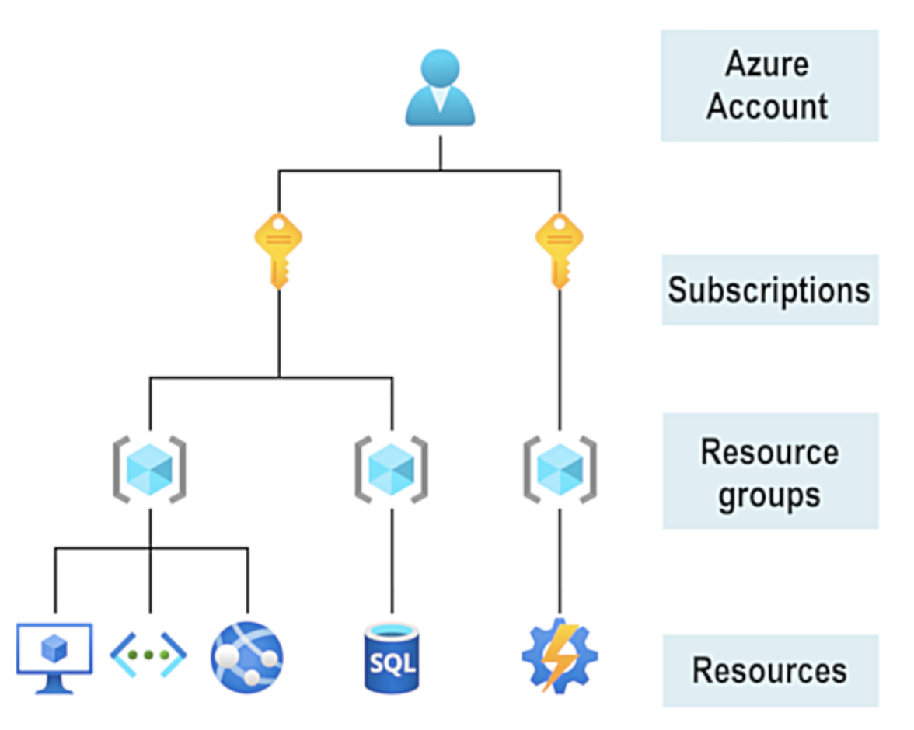

### **Physical Infrastructure**

Throughout your journey with Microsoft Azure, you’ll hear and use terms like Regions, Availability Zones, Resources, Subscriptions, and more. This module focuses on the core architectural components of Azure. The core architectural components of Azure may be broken down into two main groupings: the physical infrastructure, and the management infrastructure.

The physical infrastructure for Azure starts with datacenters. Conceptually, the datacenters are the same as large corporate **datacenters**. They’re facilities with resources arranged in racks, with dedicated power, cooling, and networking infrastructure.

As a global cloud provider, Azure has datacenters around the world. However, these individual datacenters aren’t directly accessible. Datacenters are grouped into Azure Regions or Azure Availability Zones that are designed to help you achieve resiliency and reliability for your business-critical workloads.

#### **Regions**

A region is a geographical area on the planet that contains at least one, but potentially multiple datacenters that are nearby and networked together with a low-latency network. Azure intelligently assigns and controls the resources within each region to ensure workloads are appropriately balanced.

When you deploy a resource in Azure, you'll often need to choose the region where you want your resource deployed.

Note: Some services or virtual machine (VM) features are only available in certain regions, such as specific VM sizes or storage types. There are also some global Azure services that don't require you to select a particular region, such as Microsoft Entra ID, Azure Traffic Manager, and Azure DNS.

#### **Availability Zones**

Availability zones are physically separate datacenters within an Azure region. Each availability zone is made up of one or more datacenters equipped with independent power, cooling, and networking. An availability zone is set up to be an isolation boundary. If one zone goes down, the other continues working. Availability zones are connected through high-speed, private fiber-optic networks.

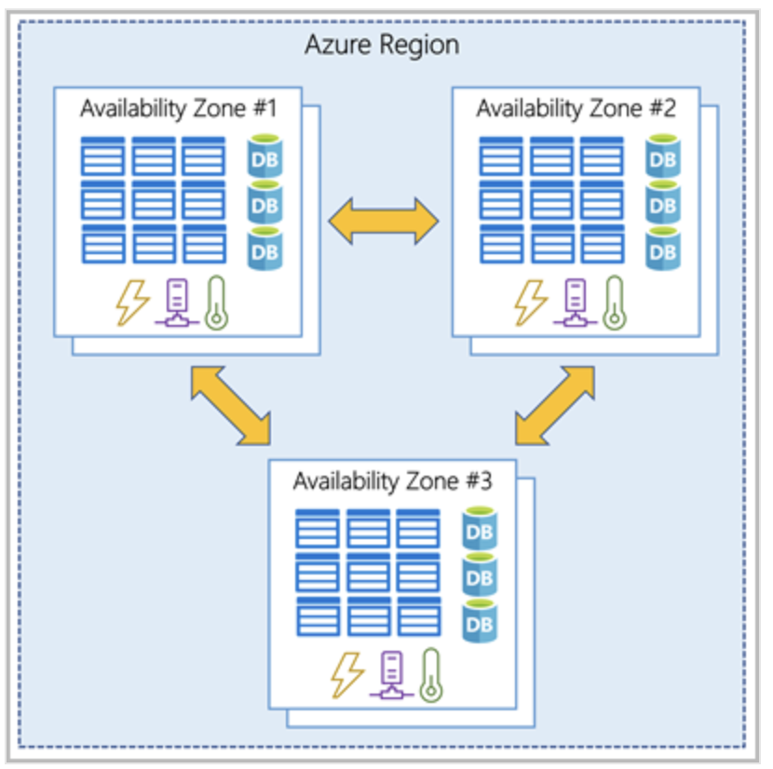

IMPORTANT: To ensure resiliency, a minimum of three separate availability zones are present in all availability zone-enabled regions. However, not all Azure Regions currently support availability zones.

**Use availability zones in your apps**

You want to ensure your services and data are redundant so you can protect your information in case of failure. When you host your infrastructure, setting up your own redundancy requires that you create duplicate hardware environments. Azure can help make your app highly available through availability zones.

You can use availability zones to run mission-critical applications and build high-availability into your application architecture by co-locating your compute, storage, networking, and data resources within an availability zone and replicating in other availability zones. Keep in mind that there could be a cost to duplicating your services and transferring data between availability zones.

Availability zones are primarily for VMs, managed disks, load balancers, and SQL databases. Azure services that support availability zones fall into three categories:

* Zonal services: You pin the resource to a specific zone (for example, VMs, managed disks, IP addresses).
* Zone-redundant services: The platform replicates automatically across zones (for example, zone-redundant storage, SQL Database).
* Non-regional services: Services are always available from Azure geographies and are resilient to zone-wide outages as well as region-wide outages.

Even with the additional resiliency that availability zones provide, it’s possible that an event could be so large that it impacts multiple availability zones in a single region. To provide even further resilience, Azure has Region Pairs.

#### **Region pairs**

Most Azure regions are paired with another region within the same geography (such as US, Europe, or Asia) at least 300 miles away. This approach allows for the replication of resources across a geography that helps reduce the likelihood of interruptions because of events such as natural disasters, civil unrest, power outages, or physical network outages that affect an entire region. For example, if a region in a pair was affected by a natural disaster, services would automatically fail over to the other region in its region pair.

IMPORTANT: Not all Azure services automatically replicate data or automatically fall back from a failed region to cross-replicate to another enabled region. In these scenarios, recovery and replication must be configured by the customer.

Examples of region pairs in Azure are West US paired with East US and South-East Asia paired with East Asia. Because the pair of regions are directly connected and far enough apart to be isolated from regional disasters, you can use them to provide reliable services and data redundancy.

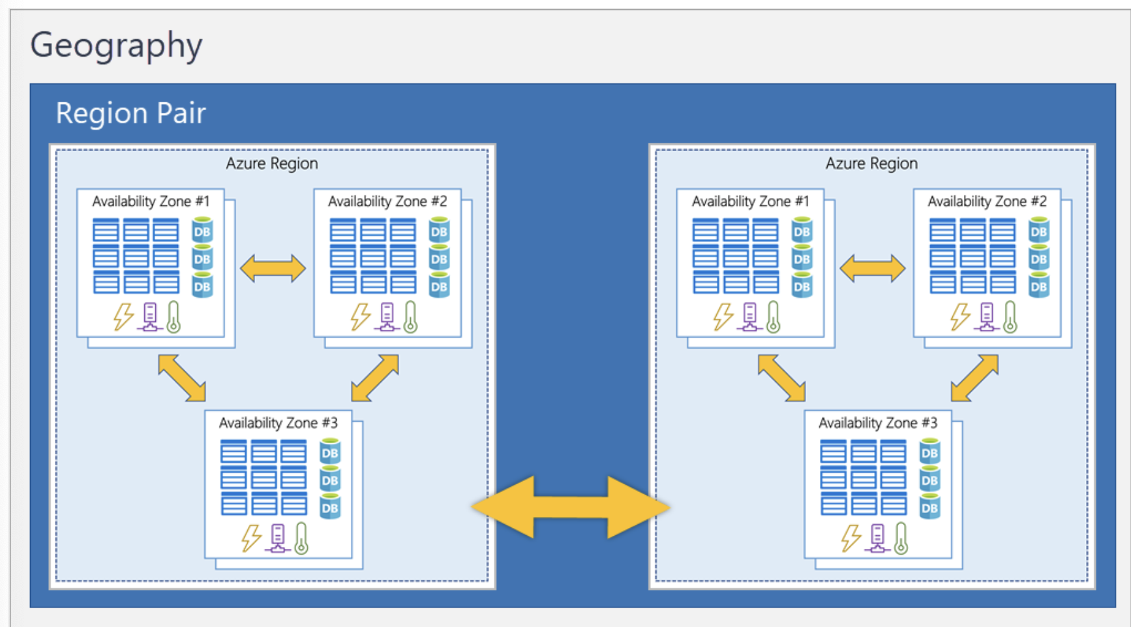

**Additional advantages of region pairs:**

* If an extensive Azure outage occurs, one region out of every pair is prioritized to make sure at least one is restored as quickly as possible for applications hosted in that region pair.
* Planned Azure updates are rolled out to paired regions one region at a time to minimize downtime and risk of application outage.
* Data continues to reside within the same geography as its pair (except for Brazil South) for tax- and law-enforcement jurisdiction purposes.

IMPORTANT: Most regions are paired in two directions, meaning they are the backup for the region that provides a backup for them (West US and East US back each other up). However, some regions, such as West India and Brazil South, are paired in only one direction. In a one-direction pairing, the Primary region does not provide backup for its secondary region. So, even though West India’s secondary region is South India, South India does not rely on West India. West India's secondary region is South India, but South India's secondary region is Central India. Brazil South is unique because it's paired with a region outside of its geography. Brazil South's secondary region is South Central US. The secondary region of South Central US isn't Brazil South.

#### **Sovereign Regions**

In addition to regular regions, Azure also has sovereign regions. Sovereign regions are instances of Azure that are isolated from the main instance of Azure. You may need to use a sovereign region for compliance or legal purposes.

* US DoD Central, US Gov Virginia, US Gov Iowa and more: These regions are physical and logical network-isolated instances of Azure for U.S. government agencies and partners. These datacenters are operated by screened U.S. personnel and include additional compliance certifications.
* China East, China North, and more: These regions are available through a unique partnership between Microsoft and 21Vianet, whereby Microsoft doesn't directly maintain the datacenters.

### **Management Infrastructure**

The management infrastructure includes Azure resources and resource groups, subscriptions, and accounts. Understanding the hierarchical organization will help you plan your projects and products within Azure.

#### **Azure resources and resource groups**

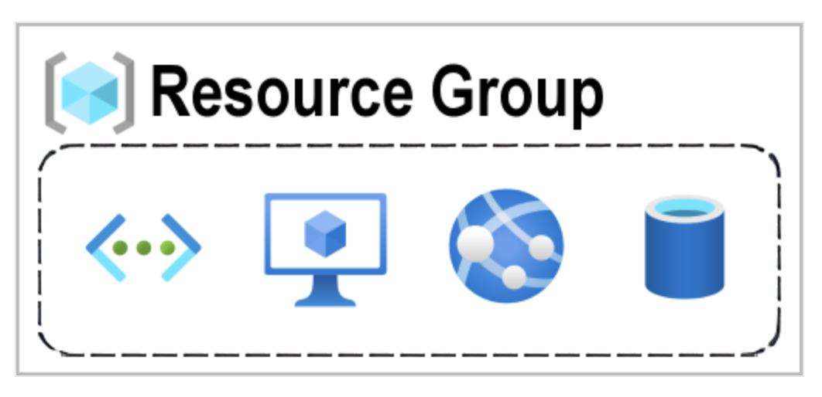

A resource is the basic building block of Azure. Anything you create, provision, deploy, etc. is a resource. Virtual Machines (VMs), virtual networks, databases, cognitive services, etc. are all considered resources within Azure.

Resource groups are simply groupings of resources. When you create a resource, you’re required to place it into a resource group. While a resource group can contain many resources, a single resource can only be in one resource group at a time. Some resources may be moved between resource groups, but when you move a resource to a new group, it will no longer be associated with the former group. Additionally, resource groups can't be nested, meaning you can’t put resource group B inside of resource group A.

Resource groups provide a convenient way to group resources together. When you apply an action to a resource group, that action will apply to all the resources within the resource group. If you delete a resource group, all the resources will be deleted. If you grant or deny access to a resource group, you’ve granted or denied access to all the resources within the resource group.

When you’re provisioning resources, it’s good to think about the resource group **structure** that best suits your needs.

For example, if you’re setting up a temporary dev environment, grouping all the resources together means you can deprovision all of the associated resources at once by deleting the resource group. If you’re provisioning compute resources that will need three different access schemas, it may be best to group resources based on the access schema, and then assign access at the resource group level.

There aren’t hard rules about how you use resource groups, so consider how to set up your resource groups to maximize their usefulness for you.

#### **Azure subscriptions**

In Azure, subscriptions are a unit of management, billing, and scale. Similar to how resource groups are a way to logically organize resources, subscriptions allow you to logically organize your resource groups and facilitate billing.

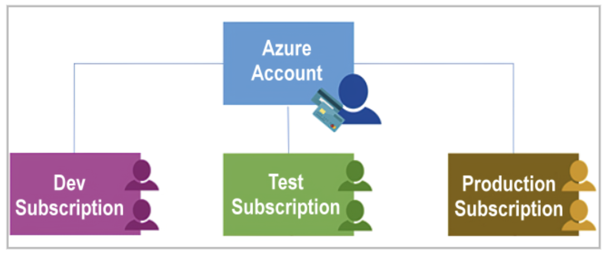

Using Azure requires an Azure subscription. A subscription provides you with authenticated and authorized access to Azure products and services. It also allows you to provision resources. An Azure subscription links to an Azure account, which is an identity in Microsoft Entra ID or in a directory that Microsoft Entra ID trusts.

An account can have multiple subscriptions, but it’s only required to have one. In a multi-subscription account, you can use the subscriptions to configure different billing models and apply different access-management policies. You can use Azure subscriptions to define boundaries around Azure products, services, and resources. There are two types of subscription boundaries that you can use:

* **Billing boundary**: This subscription type determines how an Azure account is billed for using Azure. You can create multiple subscriptions for different types of billing requirements. Azure generates separate billing reports and invoices for each subscription so that you can organize and manage costs.
* **Access control boundary**: Azure applies access-management policies at the subscription level, and you can create separate subscriptions to reflect different organizational structures. An example is that within a business, you have different departments to which you apply distinct Azure subscription policies. This billing model allows you to manage and control access to the resources that users provision with specific subscriptions.

**Create additional Azure subscriptions**

Similar to using resource groups to separate resources by function or access, you might want to create additional subscriptions for resource or billing management purposes. For example, you might choose to create additional subscriptions to separate:

* **Environments**: You can choose to create subscriptions to set up separate environments for development and testing, security, or to isolate data for compliance reasons. This design is particularly useful because resource access control occurs at the subscription level.
* **Organizational structures:** You can create subscriptions to reflect different organizational structures. For example, you could limit one team to lower-cost resources, while allowing the IT department a full range. This design allows you to manage and control access to the resources that users provision within each subscription.
* **Billing:** You can create additional subscriptions for billing purposes. Because costs are first aggregated at the subscription level, you might want to create subscriptions to manage and track costs based on your needs. For instance, you might want to create one subscription for your production workloads and another subscription for your development and testing workloads.

#### **Azure management groups**

The final piece is the management group. Resources are gathered into resource groups, and resource groups are gathered into subscriptions. If you’re just starting in Azure that might seem like enough hierarchy to keep things organized. But imagine if you’re dealing with multiple applications, multiple development teams, in multiple geographies.

If you have many subscriptions, you might need a way to efficiently manage access, policies, and compliance for those subscriptions. Azure management groups provide a level of scope above subscriptions. You organize subscriptions into containers called management groups and apply governance conditions to the management groups. All subscriptions within a management group automatically inherit the conditions applied to the management group, the same way that resource groups inherit settings from subscriptions and resources inherit from resource groups. Management groups give you enterprise-grade management at a large scale, no matter what type of subscriptions you might have. Management groups can be nested.

**Management group, subscriptions, and resource group hierarchy**

You can build a flexible structure of management groups and subscriptions to organize your resources into a hierarchy for unified policy and access management. The following diagram shows an example of creating a hierarchy for governance by using management groups.

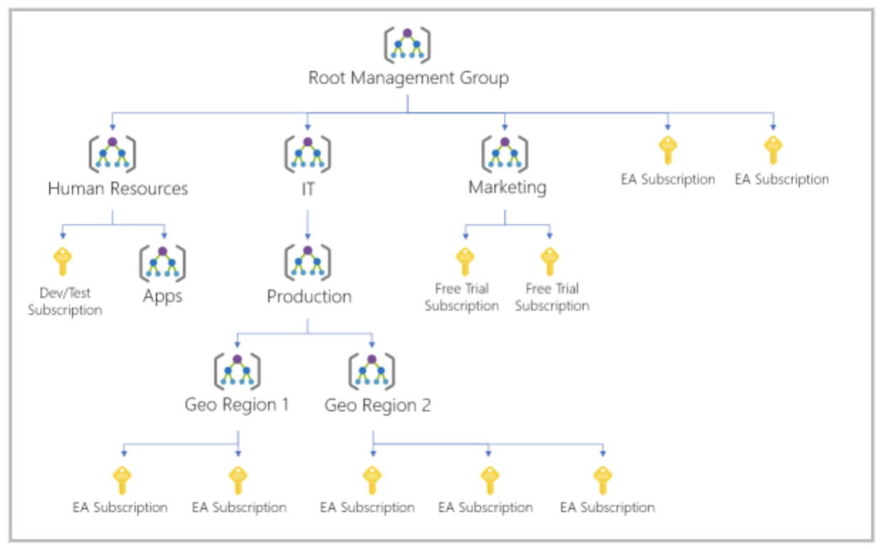

Some examples of how you could use management groups might be:

* Create a hierarchy that applies a policy. You could limit VM locations to the US West Region in a group called Production. This policy will inherit onto all the subscriptions that are descendants of that management group and will apply to all VMs under those subscriptions. This security policy can't be altered by the resource or subscription owner, which allows for improved governance.
* Provide user access to multiple subscriptions. By moving multiple subscriptions under a management group, you can create one Azure role-based access control (Azure RBAC) assignment on the management group. Assigning Azure RBAC at the management group level means that all sub-management groups, subscriptions, resource groups, and resources underneath that management group would also inherit those permissions. One assignment on the management group can enable users to have access to everything they need instead of scripting Azure RBAC over different subscriptions.

Important facts about management groups:

* 10,000 management groups can be supported in a single directory.
* A management group tree can support up to six levels of depth. This limit doesn't include the root level or the subscription level.
* Each management group and subscription can support only one parent.

# azure compute and networking services

## **1. Virtual Machines (VM)**

With Azure Virtual Machines (VMs), you can create and use VMs in the cloud. VMs provide infrastructure as a service (IaaS) in the form of a virtualized server and can be used in many ways. Just like a physical computer, you can customize all of the software running on your VM. VMs are an ideal choice when you need:

* Total control over the operating system (OS).
* The ability to run custom software.
* To use custom hosting configurations.

An Azure VM gives you the flexibility of virtualization without having to buy and maintain the physical hardware that runs the VM. However, as an IaaS offering, you still need to configure, update, and maintain the software that runs on the VM.

You can even create or use an already created image to rapidly provision VMs. You can create and provision a VM in minutes when you select a preconfigured VM image. An image is a template used to create a VM and may already include an OS and other software, like development tools or web hosting environments.

### **Scale VMs in Azure**

You can run single VMs for testing, development, or minor tasks. Or you can group VMs together to provide high availability, scalability, and redundancy. Azure can also manage the grouping of VMs for you with features such as scale sets and availability sets.

#### **Virtual machine scale sets**

Virtual machine scale sets let you create and manage a group of identical, load-balanced VMs. If you simply created multiple VMs with the same purpose, you’d need to ensure they were all configured identically and then set up network routing parameters to ensure efficiency. You’d also have to monitor the utilization to determine if you need to increase or decrease the number of VMs.

Instead, with virtual machine scale sets, Azure automates most of that work. Scale sets allow you to centrally manage, configure, and update a large number of VMs in minutes. The number of VM instances can automatically increase or decrease in response to demand, or you can set it to scale based on a defined schedule. Virtual machine scale sets also automatically deploy a load balancer to make sure that your resources are being used efficiently. With virtual machine scale sets, you can build large-scale services for areas such as compute, big data, and container workloads.

#### **Virtual machine availability sets**

Virtual machine availability sets are another tool to help you build a more resilient, highly available environment. Availability sets are designed to ensure that VMs stagger updates and have varied power and network connectivity, preventing you from losing all your VMs with a single network or power failure.They do this by grouping VMs in two ways: update domain and fault domain.

* **Update domain:** The update domain groups VMs that can be rebooted at the same time. This allows you to apply updates while knowing that only one update domain grouping will be offline at a time. All of the machines in one update domain will be updated. An update group going through the update process is given a 30-minute time to recover before maintenance on the next update domain starts.
* **Fault domain**: The fault domain groups your VMs by common power source and network switch. By default, an availability set will split your VMs across up to three fault domains. This helps protect against a physical power or networking failure by having VMs in different fault domains (thus being connected to different power and networking resources).

Best of all, there’s no additional cost for configuring an availability set. You only pay for the VM instances you create.

**Examples of when to use VMs**

Some common examples or use cases for virtual machines include:

* **During testing and development.** VMs provide a quick and easy way to create different OS and application configurations. Test and development personnel can then easily delete the VMs when they no longer need them.
* **When running applications in the cloud**. The ability to run certain applications in the public cloud as opposed to creating a traditional infrastructure to run them can provide substantial economic benefits. For example, an application might need to handle fluctuations in demand. Shutting down VMs when you don't need them or quickly starting them up to meet a sudden increase in demand means you pay only for the resources you use.
* **When extending your datacenter to the cloud**: An organization can extend the capabilities of its own on-premises network by creating a virtual network in Azure and adding VMs to that virtual network. Applications like SharePoint can then run on an Azure VM instead of running locally. This arrangement makes it easier or less expensive to deploy than in an on-premises environment.
* **During disaster recovery:** As with running certain types of applications in the cloud and extending an on-premises network to the cloud, you can get significant cost savings by using an IaaS-based approach to disaster recovery. If a primary datacenter fails, you can create VMs running on Azure to run your critical applications and then shut them down when the primary datacenter becomes operational again.

**Move to the cloud with VM**

VMs are also an excellent choice when you move from a physical server to the cloud (also known as lift and shift). You can create an image of the physical server and host it within a VM with little or no changes. Just like a physical on-premises server, you must maintain the VM: you’re responsible for maintaining the installed OS and software.

**Resources**

When you provision a VM, you’ll also have the chance to pick the resources that are associated with that VM, including:

* Size (purpose, number of processor cores, and amount of RAM)
* Storage disks (hard disk drives, solid state drives, etc.)
* Networking (virtual network, public IP address, and port configuration)

## **2. Azure Virtual Desktop**

Another type of virtual machine is the Azure Virtual Desktop. Azure Virtual Desktop is a desktop and application virtualization service that runs on the cloud. It enables you to use a cloud-hosted version of Windows from any location. Azure Virtual Desktop works across devices and operating systems, and works with apps that you can use to access remote desktops or most modern browsers.

### **Enhance security**

Azure Virtual Desktop provides centralized security management for users' desktops with Microsoft Entra ID. You can enable multifactor authentication to secure user sign-ins. You can also secure access to data by assigning granular role-based access controls (RBACs) to users.

With Azure Virtual Desktop, the data and apps are separated from the local hardware. The actual desktop and apps are running in the cloud, meaning the risk of confidential data being left on a personal device is reduced. Additionally, user sessions are isolated in both single and multi-session environments.

### **Multi-session Windows 10 or Windows 11 deployment**

Azure Virtual Desktop lets you use Windows 10 or Windows 11 Enterprise multi-session, the only Windows client-based operating system that enables multiple concurrent users on a single VM. Azure Virtual Desktop also provides a more consistent experience with broader application support compared to Windows Server-based operating systems.

## **3. Containers**

While virtual machines are an excellent way to reduce costs versus the investments that are necessary for physical hardware, they're still limited to a single operating system per virtual machine. If you want to run multiple instances of an application on a single host machine, containers are an excellent choice. One of the most popular container engines is Docker, and Azure supports Docker.

### **What are containers?**

Containers are a virtualization environment. Much like running multiple virtual machines on a single physical host, you can run multiple containers on a single physical or virtual host.

* Unlike virtual machines, you don't manage the operating system for a container. Virtual machines appear to be an instance of an operating system that you can connect to and manage. Containers are lightweight and designed to be created, scaled out, and stopped dynamically.
* It's possible to create and deploy virtual machines as application demand increases, but containers are a lighter weight, more agile method. Containers are designed to allow you to respond to changes on demand: With containers, you can quickly restart if there's a crash or hardware interruption.

#### **Azure Container Instances**

Azure Container Instances offer the fastest and simplest way to run a container in Azure; without having to manage any virtual machines or adopt any additional services. Azure Container Instances are a platform as a service (PaaS) offering. Azure Container Instances allow you to upload your containers and then the service will run the containers for you.

#### **Azure Container Apps**

Azure Container Apps are similar in many ways to a container instance. They allow you to get up and running right away, they remove the container management piece, and they're a PaaS offering. Container Apps have extra benefits such as the ability to incorporate load balancing and scaling. These other functions allow you to be more elastic in your design.

#### **Azure Kubernetes Service**

Azure Kubernetes Service (AKS) is a container orchestration service. An orchestration service manages the lifecycle of containers. When you're deploying a fleet of containers, AKS can make fleet management simpler and more efficient.

#### **Use containers in your solutions**

Containers are often used to create solutions by using a microservice architecture. This architecture is where you break solutions into smaller, independent pieces. For example, you might split a website into a container hosting your front end, another hosting your back end, and a third for storage. This split allows you to separate portions of your app into logical sections that can be maintained, scaled, or updated independently.

Imagine your website back-end has reached capacity but the front end and storage aren't being stressed. With containers, you could scale the back end separately to improve performance. If something necessitated such a change, you could also choose to change the storage service or modify the front end without impacting any of the other components.

## **4. Azure functions**

Azure Functions is an event-driven, serverless compute option that doesn’t require maintaining virtual machines or containers. If you build an app using VMs or containers, those resources have to be “running” in order for your app to function. With Azure Functions, an event wakes the function, alleviating the need to keep resources provisioned when there are no events.

### **Benefits of Azure functions**

* Using Azure Functions is ideal when you're only concerned about the code running your service and not about the underlying platform or infrastructure. Functions are commonly used when you need to perform work in response to an event (often via a REST request), timer, or message from another Azure service, and when that work can be completed quickly, within seconds or less.
* Functions scale automatically based on demand, so they may be a good choice when demand is variable.
* Azure Functions runs your code when it's triggered and automatically deallocates resources when the function is finished. In this model, you're only charged for the CPU time used while your function runs.
* Functions can be either stateless or stateful. When they're stateless (the default), they behave as if they're restarted every time they respond to an event. When they're stateful (called Durable Functions), a context is passed through the function to track prior activity.
* Functions are a key component of serverless computing. They're also a general compute platform for running any type of code. If the needs of the developer's app change, you can deploy the project in an environment that isn't serverless. This flexibility allows you to manage scaling, run on virtual networks, and even completely isolate the functions

## **5. Application hosting options**

If you need to host your application on Azure, you might initially turn to a virtual machine (VM) or containers. Both VMs and containers provide excellent hosting solutions. VMs give you maximum control of the hosting environment and allow you to configure it exactly how you want. VMs also may be the most familiar hosting method if you’re new to the cloud. Containers, with the ability to isolate and individually manage different aspects of the hosting solution, can also be a robust and compelling option.

There are other hosting options that you can use with Azure, including Azure App Service.

### **Azure App Service**

App Service enables you to build and host web apps, background jobs, mobile back-ends, and RESTful APIs in the programming language of your choice without managing infrastructure. It offers automatic scaling and high availability. App Service supports Windows and Linux. It enables automated deployments from GitHub, Azure DevOps, or any Git repo to support a continuous deployment model.

Azure App Service is a robust hosting option that you can use to host your apps in Azure. Azure App Service lets you focus on building and maintaining your app, and Azure focuses on keeping the environment up and running.

Azure App Service is an HTTP-based service for hosting web applications, REST APIs, and mobile back ends. It supports multiple languages, including .NET, .NET Core, Java, Ruby, Node.js, PHP, or Python. It also supports both Windows and Linux environments.

**Types of app services**

App Service handles most of the infrastructure decisions you deal with in hosting web-accessible apps:

* Deployment and management are integrated into the platform.
* Endpoints can be secured.
* Sites can be scaled quickly to handle high traffic loads.
* The built-in load balancing and traffic manager provide high availability.

All of these app styles are hosted in the same infrastructure and share these benefits. This flexibility makes App Service the ideal choice to host web-oriented applications.

#### **Web apps**

App Service includes full support for hosting web apps by using ASP.NET, ASP.NET Core, Java, Ruby, Node.js, PHP, or Python. You can choose either Windows or Linux as the host operating system.

#### **API apps**

Much like hosting a website, you can build REST-based web APIs by using your choice of language and framework. You get full Swagger support and the ability to package and publish your API in Azure Marketplace. The produced apps can be consumed from any HTTP- or HTTPS-based client.

#### **WebJobs**

You can use the WebJobs feature to run a program (.exe, Java, PHP, Python, or Node.js) or script (.cmd, .bat, PowerShell, or Bash) in the same context as a web app, API app, or mobile app. They can be scheduled or run by a trigger. WebJobs are often used to run background tasks as part of your application logic.

#### **Mobile apps**

Use the Mobile Apps feature of App Service to quickly build a backend for iOS and Android apps. With just a few actions in the Azure portal, you can:

* Store mobile app data in a cloud-based SQL database.
* Authenticate customers against common social providers, such as MSA, Google, Twitter, and Facebook.
* Send push notifications.
* Execute custom back-end logic in C# or Node.js.
* On the mobile app side, there's SDK support for native iOS and Android, Xamarin, and React native apps.

## **6. Azure virtual networking**

Azure virtual networks and virtual subnets enable Azure resources, such as VMs, web apps, and databases, to communicate with each other, with users on the internet, and with your on-premises client computers. You can think of an Azure network as an extension of your on-premises network with resources that link other Azure resources.

Azure virtual networks provide the following key networking capabilities:

* Isolation and segmentation
* Internet communications
* Communicate between Azure resources
* Communicate with on-premises resources
* Route network traffic
* Filter network traffic
* Connect virtual networks

Azure virtual networking supports both public and private endpoints to enable communication between external or internal resources with other internal resources.

* Public endpoints have a public IP address and can be accessed from anywhere in the world.
* Private endpoints exist within a virtual network and have a private IP address from within the address space of that virtual network.

### **Isolation and segmentation**

Azure virtual network allows you to create multiple isolated virtual networks. When you set up a virtual network, you define a private IP address space by using either public or private IP address ranges. The IP range only exists within the virtual network and isn't internet routable. You can divide that IP address space into subnets and allocate part of the defined address space to each named subnet.

For name resolution, you can use the name resolution service that's built into Azure. You also can configure the virtual network to use either an internal or an external DNS server.

### **Internet communications**

You can enable incoming connections from the internet by assigning a public IP address to an Azure resource, or putting the resource behind a public load balancer.

### **Communicate between Azure resources**

You'll want to enable Azure resources to communicate securely with each other. You can do that in one of two ways:

* **Virtual networks** can connect not only VMs but other Azure resources, such as the App Service Environment for Power Apps, Azure Kubernetes Service, and Azure virtual machine scale sets.
* **Service endpoints** can connect to other Azure resource types, such as Azure SQL databases and storage accounts. This approach enables you to link multiple Azure resources to virtual networks to improve security and provide optimal routing between resources.

### **Communicate with on-premises resources**

Azure virtual networks enable you to link resources together in your on-premises environment and within your Azure subscription. In effect, you can create a network that spans both your local and cloud environments. There are three mechanisms for you to achieve this connectivity:

* **Point-to-site** virtual private network connections are from a computer outside your organization back into your corporate network. In this case, the client computer initiates an encrypted VPN connection to connect to the Azure virtual network.
* **Site-to-site** virtual private networks link your on-premises VPN device or gateway to the Azure VPN gateway in a virtual network. In effect, the devices in Azure can appear as being on the local network. The connection is encrypted and works over the internet.
* **Azure ExpressRoute** provides a dedicated private connectivity to Azure that doesn't travel over the internet. ExpressRoute is useful for environments where you need greater bandwidth and even higher levels of security.

### 

### **Route network traffic**

By default, Azure routes traffic between subnets on any connected virtual networks, on-premises networks, and the internet. You also can control routing and override those settings, as follows:

* **Route tables** allow you to define rules about how traffic should be directed. You can create custom route tables that control how packets are routed between subnets.
* **Border Gateway Protocol (BGP)** works with Azure VPN gateways, Azure Route Server, or Azure ExpressRoute to propagate on-premises BGP routes to Azure virtual networks.

### 

### **Filter network traffic**

Azure virtual networks enable you to filter traffic between subnets by using the following approaches:

* **Network security groups (NSG)** are Azure resources that can contain multiple inbound and outbound security rules. You can define these rules to allow or block traffic, based on factors such as source and destination IP address, port, and protocol.
* **Network virtual appliances (NVA)** are specialized VMs that can be compared to a hardened network appliance. A network virtual appliance carries out a particular network function, such as running a firewall or performing wide area network (WAN) optimization.

### **Connect virtual networks**

You can link virtual networks together by using virtual **network peering**. Peering allows two virtual networks to connect directly to each other. Network traffic between peered networks is private, and travels on the Microsoft backbone network, never entering the public internet. Peering enables resources in each virtual network to communicate with each other. These virtual networks can be in separate regions, which allows you to create a global interconnected network through Azure.

**User-defined routes (UDR)** allow you to control the routing tables between subnets within a virtual network or between virtual networks. This allows for greater control over network traffic flow.

## **7. Azure virtual private networks**

A virtual private network (VPN) uses an encrypted tunnel within another network. VPNs are typically deployed to connect two or more trusted private networks to one another over an untrusted network (typically the public internet). Traffic is encrypted while traveling over the untrusted network to prevent eavesdropping or other attacks. VPNs can enable networks to safely and securely share sensitive information.

### **VPN gateways**

A VPN gateway is a type of virtual network gateway. Azure VPN Gateway instances are deployed in a dedicated subnet of the virtual network and enable the following connectivity:

* Connect on-premises datacenters to virtual networks through a **site-to-site** connection.
* Connect individual devices to virtual networks through a **point-to-site** connection.
* Connect virtual networks to other virtual networks through a **network-to-network** connection.

All data transfer is encrypted inside a private tunnel as it crosses the internet. You can deploy only one VPN gateway in each virtual network. However, you can use one gateway to connect to multiple locations, which includes other virtual networks or on-premises datacenters.

When setting up a VPN gateway, you must specify the type of VPN - either policy-based or route-based. The primary distinction between these two types is how they determine which traffic needs encryption. In Azure, regardless of the VPN type, the method of authentication employed is a pre-shared key.

* **Policy-based VPN** gateways specify statically the IP address of packets that should be encrypted through each tunnel. This type of device evaluates every data packet against those sets of IP addresses to choose the tunnel where that packet is going to be sent through.
* **In Route-based gateways,** IPSec tunnels are modeled as a network interface or virtual tunnel interface. IP routing (either static routes or dynamic routing protocols) decides which one of these tunnel interfaces to use when sending each packet. Route-based VPNs are the preferred connection method for on-premises devices. They're more resilient to topology changes such as the creation of new subnets.

Use a route-based VPN gateway if you need any of the following types of connectivity:

* Connections between virtual networks
* Point-to-site connections
* Multisite connections
* Coexistence with an Azure ExpressRoute gateway

### **High-availability scenarios**

If you’re configuring a VPN to keep your information safe, you also want to be sure that it’s a highly available and fault tolerant VPN configuration. There are a few ways to maximize the resiliency of your VPN gateway.

#### **Active/standby**

By default, VPN gateways are deployed as two instances in an active/standby configuration, even if you only see one VPN gateway resource in Azure. When planned maintenance or unplanned disruption affects the active instance, the standby instance automatically assumes responsibility for connections without any user intervention. Connections are interrupted during this failover, but they're typically restored within a few seconds for planned maintenance and within 90 seconds for unplanned disruptions.

#### **Active/active**

With the introduction of support for the BGP routing protocol, you can also deploy VPN gateways in an active/active configuration. In this configuration, you assign a unique public IP address to each instance. You then create separate tunnels from the on-premises device to each IP address. You can extend the high availability by deploying an additional VPN device on-premises.

#### **ExpressRoute failover**

Another high-availability option is to configure a VPN gateway as a secure failover path for ExpressRoute connections. ExpressRoute circuits have resiliency built in. However, they aren't immune to physical problems that affect the cables delivering connectivity or outages that affect the complete ExpressRoute location. In high-availability scenarios, where there's risk associated with an outage of an ExpressRoute circuit, you can also provision a VPN gateway that uses the internet as an alternative method of connectivity. In this way, you can ensure there's always a connection to the virtual networks.

#### **Zone-redundant gateways**

In regions that support availability zones, VPN gateways and ExpressRoute gateways can be deployed in a zone-redundant configuration. This configuration brings resiliency, scalability, and higher availability to virtual network gateways. Deploying gateways in Azure availability zones physically and logically separates gateways within a region while protecting your on-premises network connectivity to Azure from zone-level failures. These gateways require different gateway stock keeping units (SKUs) and use Standard public IP addresses instead of Basic public IP addresses.

## **8. Azure Express Route**

Azure ExpressRoute lets you extend your on-premises networks into the Microsoft cloud over a private connection, with the help of a connectivity provider. This connection is called an ExpressRoute Circuit. With ExpressRoute, you can establish connections to Microsoft cloud services, such as Microsoft Azure and Microsoft 365. This allows you to connect offices, datacenters, or other facilities to the Microsoft cloud. Each location would have its own ExpressRoute circuit.

Connectivity can be from an any-to-any (IP VPN) network, a point-to-point Ethernet network, or a virtual cross-connection through a connectivity provider at a colocation facility. ExpressRoute connections don't go over the public Internet. This allows ExpressRoute connections to offer more reliability, faster speeds, consistent latencies, and higher security than typical connections over the Internet.

### **Features and benefits of ExpressRoute**

There are several benefits to using ExpressRoute as the connection service between Azure and on-premises networks.

* Connectivity to Microsoft cloud services across all regions in the geopolitical region.
* Global connectivity to Microsoft services across all regions with the ExpressRoute Global Reach.
* Dynamic routing between your network and Microsoft via Border Gateway Protocol (BGP).
* Built-in redundancy in every peering location for higher reliability.

#### **Connectivity to Microsoft cloud services**

ExpressRoute enables direct access to the following services in all regions:

* Microsoft Office 365
* Microsoft Dynamics 365
* Azure compute services, such as Azure Virtual Machines
* Azure cloud services, such as Azure Cosmos DB and Azure Storage

#### 

#### **Global connectivity**

You can enable ExpressRoute Global Reach to exchange data across your on-premises sites by connecting your ExpressRoute circuits. For example, say you had an office in Asia and a datacenter in Europe, both with ExpressRoute circuits connecting them to the Microsoft network. You could use ExpressRoute Global Reach to connect those two facilities, allowing them to communicate without transferring data over the public internet.

#### **Dynamic routing**

ExpressRoute uses the BGP. BGP is used to exchange routes between on-premises networks and resources running in Azure. This protocol enables dynamic routing between your on-premises network and services running in the Microsoft cloud.

#### **Built-in redundancy**

Each connectivity provider uses redundant devices to ensure that connections established with Microsoft are highly available. You can configure multiple circuits to complement this feature.

### **ExpressRoute connectivity models**

ExpressRoute supports 4 models that you can use to connect your on-premises network to the Microsoft cloud:

#### **Co-location at a cloud exchange**

Co-location refers to your datacenter, office, or other facility being physically co-located at a cloud exchange, such as an ISP. If your facility is co-located at a cloud exchange, you can request a virtual cross-connect to the Microsoft cloud.

#### **Point-to-point Ethernet connection**

Point-to-point ethernet connection refers to using a point-to-point connection to connect your facility to the Microsoft cloud.

#### **Any-to-any networks**

With any-to-any connectivity, you can integrate your wide area network (WAN) with Azure by providing connections to your offices and datacenters. Azure integrates with your WAN connection to provide a connection like you would have between your datacenter and any branch offices.

#### **Directly from ExpressRoute sites**

You can connect directly into the Microsoft's global network at a peering location strategically distributed across the world. ExpressRoute Direct provides dual 100 Gbps or 10-Gbps connectivity, which supports Active/Active connectivity at scale.

### **Security considerations**

With ExpressRoute, your data doesn't travel over the public internet, so it's not exposed to the potential risks associated with internet communications. ExpressRoute is a private connection from your on-premises infrastructure to your Azure infrastructure. Even if you have an ExpressRoute connection, DNS queries, certificate revocation list checking, and Azure Content Delivery Network requests are still sent over the public internet.

## **9. Azure DNS**

Azure DNS is a hosting service for DNS domains that provides name resolution by using Microsoft Azure infrastructure. By hosting your domains in Azure, you can manage your DNS records using the same credentials, APIs, tools, and billing as your other Azure services.

**Benefits of Azure DNS**

* Reliability and performance
* Security
* Ease of Use
* Customizable virtual networks
* Alias records

#### **Reliability and performance**

DNS domains in Azure DNS are hosted on Azure's global network of DNS name servers, providing resiliency and high availability. Azure DNS uses anycast networking, so each DNS query is answered by the closest available DNS server to provide fast performance and high availability for your domain.

#### **Security**

Azure DNS is based on Azure Resource Manager, which provides features such as:

* Azure role-based access control (Azure RBAC) to control who has access to specific actions for your organization.
* Activity logs to monitor how a user in your organization modified a resource or to find an error when troubleshooting.
* Resource locking to lock a subscription, resource group, or resource. Locking prevents other users in your organization from accidentally deleting or modifying critical resources.

#### **Ease of use**

Azure DNS can manage DNS records for your Azure services and provide DNS for your external resources as well. Azure DNS is integrated in the Azure portal and uses the same credentials, support contract, and billing as your other Azure services.

Because Azure DNS is running on Azure, it means you can manage your domains and records with the Azure portal, Azure PowerShell cmdlets, and the cross-platform Azure CLI. Applications that require automated DNS management can integrate with the service by using the REST API and SDKs.

#### **Customizable virtual networks with private domains**

Azure DNS also supports private DNS domains. This feature allows you to use your own custom domain names in your private virtual networks, rather than being stuck with the Azure-provided names.

#### **Alias records**

Azure DNS also supports alias record sets. You can use an alias record set to refer to an Azure resource, such as an Azure public IP address, an Azure Traffic Manager profile, or an Azure Content Delivery Network (CDN) endpoint. If the IP address of the underlying resource changes, the alias record set seamlessly updates itself during DNS resolution. The alias record set points to the service instance, and the service instance is associated with an IP address.

# azure storage services

## **Storage Accounts**

A storage account provides a unique namespace for your Azure Storage data that's accessible from anywhere in the world over HTTP or HTTPS. Data in this account is secure, highly available, durable, and massively scalable.

When you create your storage account, you’ll start by picking the storage account type. The type of account determines the storage services and redundancy options and has an impact on the use cases. Below is a list of redundancy options that will be covered later in this module:

* Locally redundant storage (LRS)
* Geo-redundant storage (GRS)
* Read-access geo-redundant storage (RA-GRS)
* Zone-redundant storage (ZRS)
* Geo-zone-redundant storage (GZRS)
* Read-access geo-zone-redundant storage (RA-GZRS)

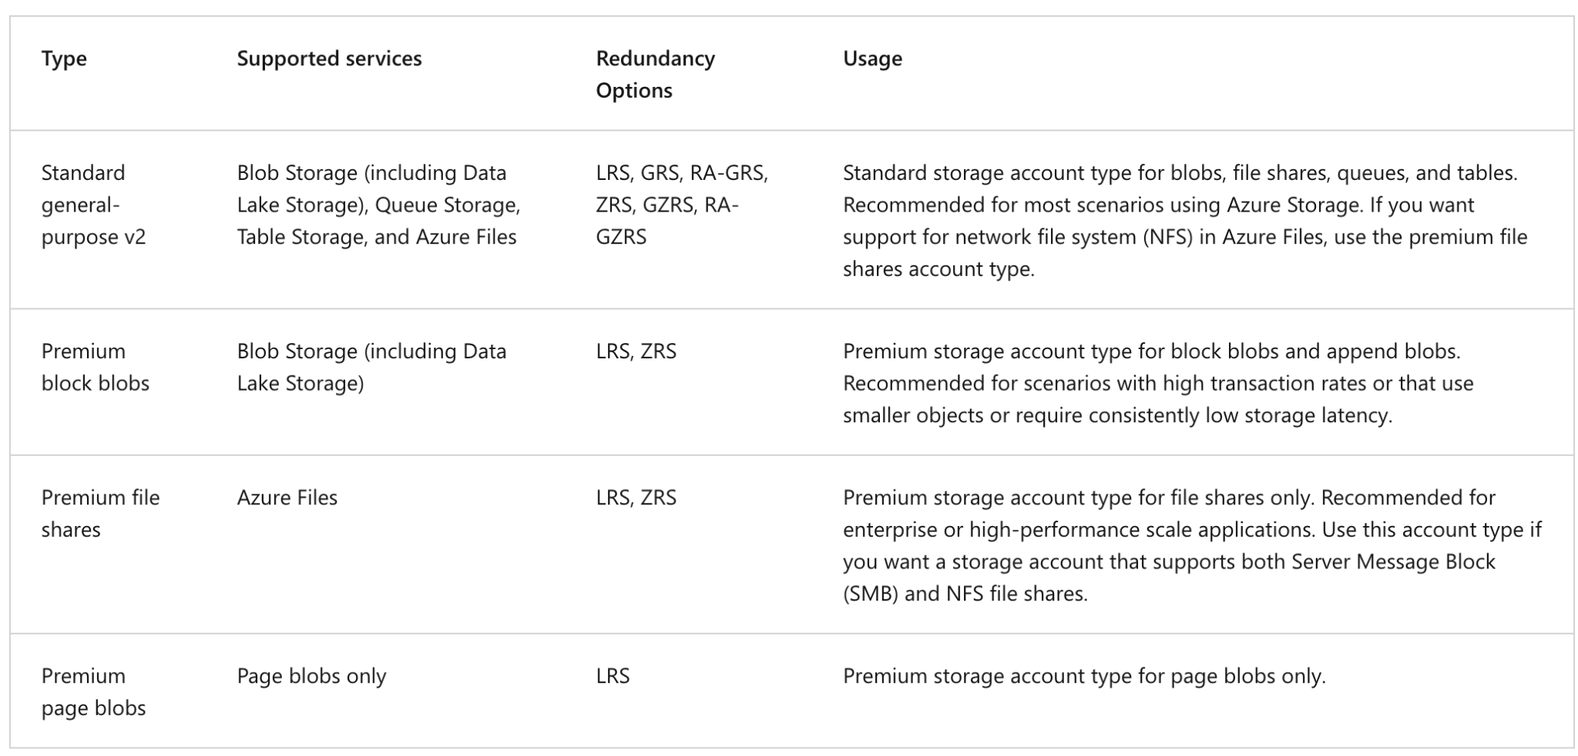

### **Storage account endpoints**

One of the benefits of using an Azure Storage Account is having a unique namespace in Azure for your data. In order to do this, every storage account in Azure must have a unique-in-Azure account name. The combination of the account name and the Azure Storage service endpoint forms the endpoints for your storage account.

When naming your storage account, keep these rules in mind:

* Storage account names must be between 3 and 24 characters in length and may contain numbers and lowercase letters only.
* Your storage account name must be unique within Azure. No two storage accounts can have the same name. This supports the ability to have a unique, accessible namespace in Azure.

The following table shows the endpoint format for Azure Storage services:

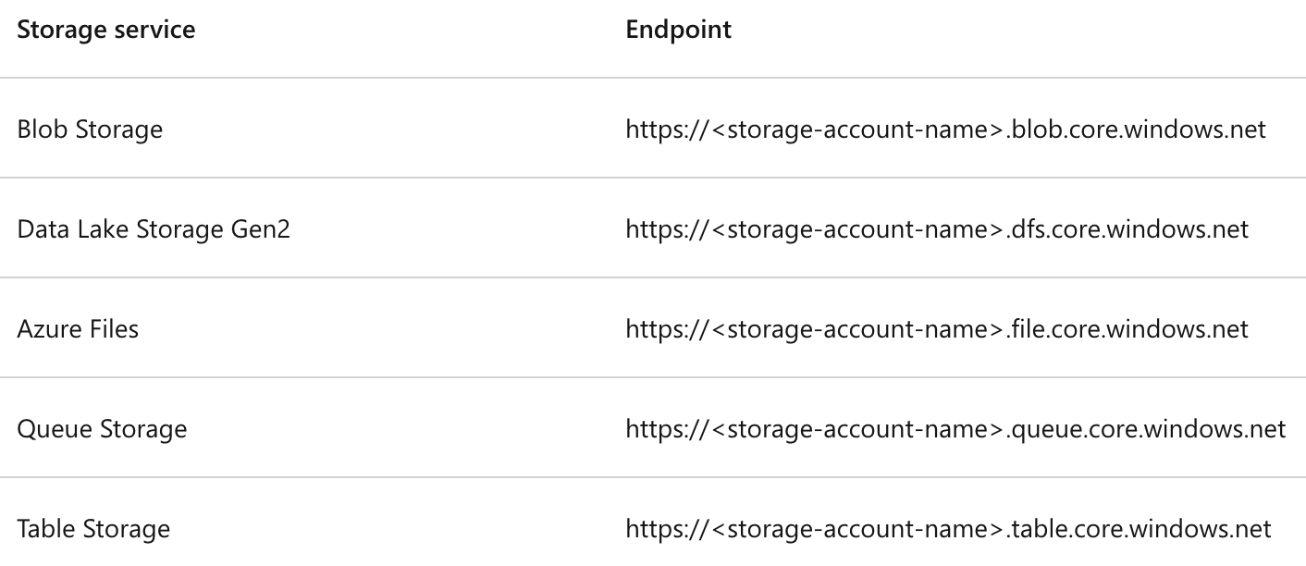

## **S**torage redundanc**y**

Azure Storage always stores multiple copies of your data so that it's protected from planned and unplanned events such as transient hardware failures, network or power outages, and natural disasters. Redundancy ensures that your storage account meets its availability and durability targets even in the face of failures.

When deciding which redundancy option is best for your scenario, consider the tradeoffs between lower costs and higher availability. The factors that help determine which redundancy option you should choose include:

* How your data is replicated in the primary region.
* Whether your data is replicated to a second region that is geographically distant to the primary region, to protect against regional disasters.
* Whether your application requires read access to the replicated data in the secondary region if the primary region becomes unavailable.

### **Redundancy in the primary region**

Data in an Azure Storage account is always replicated three times in the primary region. Azure Storage offers two options for how your data is replicated in the primary region, locally redundant storage (LRS) and zone-redundant storage (ZRS).

#### **Locally redundant storage**

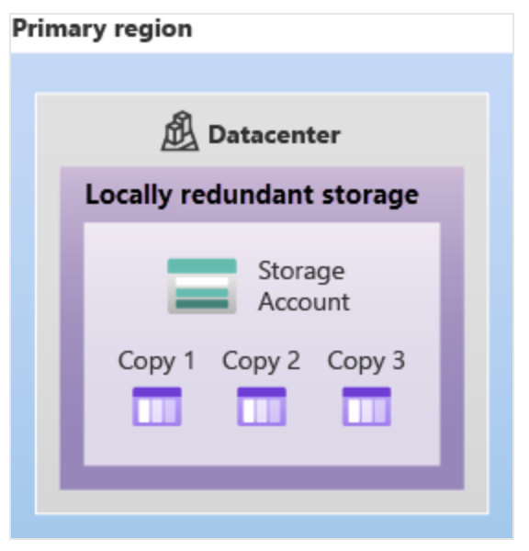

Locally redundant storage (LRS) replicates your data three times within a single data center in the primary region. LRS provides at least 11 nines of durability (99.999999999%) of objects over a given year.

LRS is the lowest-cost redundancy option and offers the least durability compared to other options. LRS protects your data against server rack and drive failures. However, if a disaster such as fire or flooding occurs within the data center, all replicas of a storage account using LRS may be lost or unrecoverable. To mitigate this risk, Microsoft recommends using zone-redundant storage (ZRS), geo-redundant storage (GRS), or geo-zone-redundant storage (GZRS).

#### **Zone-redundant storage**

For Availability Zone-enabled Regions, zone-redundant storage (ZRS) replicates your Azure Storage data synchronously across three Azure availability zones in the primary region. ZRS offers durability for Azure Storage data objects of at least 12 nines (99.9999999999%) over a given year.

With ZRS, your data is still accessible for both read and write operations even if a zone becomes unavailable. No remounting of Azure file shares from the connected clients is required. If a zone becomes unavailable, Azure undertakes networking updates, such as DNS repointing. These updates may affect your application if you access data before the updates have completed.

Microsoft recommends using ZRS in the primary region for scenarios that require high availability. ZRS is also recommended for restricting replication of data within a country or region to meet data governance requirements.

### **Redundancy in a secondary region**

For applications requiring high durability, you can choose to additionally copy the data in your storage account to a secondary region that is hundreds of miles away from the primary region. If the data in your storage account is copied to a secondary region, then your data is durable even in the event of a catastrophic failure that prevents the data in the primary region from being recovered.

When you create a storage account, you select the primary region for the account. The paired secondary region is based on Azure Region Pairs, and can't be changed.

Azure Storage offers two options for copying your data to a secondary region: geo-redundant storage (GRS) and geo-zone-redundant storage (GZRS). GRS is similar to running LRS in two regions, and GZRS is similar to running ZRS in the primary region and LRS in the secondary region.

By default, data in the secondary region isn't available for read or write access unless there's a failover to the secondary region. If the primary region becomes unavailable, you can choose to fail over to the secondary region. After the failover has completed, the secondary region becomes the primary region, and you can again read and write data.

Important: Because data is replicated to the secondary region asynchronously, a failure that affects the primary region may result in data loss if the primary region can't be recovered. The interval between the most recent writes to the primary region and the last write to the secondary region is known as the recovery point objective (RPO). The RPO indicates the point in time to which data can be recovered. Azure Storage typically has an RPO of less than 15 minutes, although there's currently no SLA on how long it takes to replicate data to the secondary region.

#### **Geo-redundant storage**

GRS copies your data synchronously three times within a single physical location in the primary region using LRS. It then copies your data asynchronously to a single physical location in the secondary region (the region pair) using LRS. GRS offers durability for Azure Storage data objects of at least 16 nines (99.99999999999999%) over a given year.

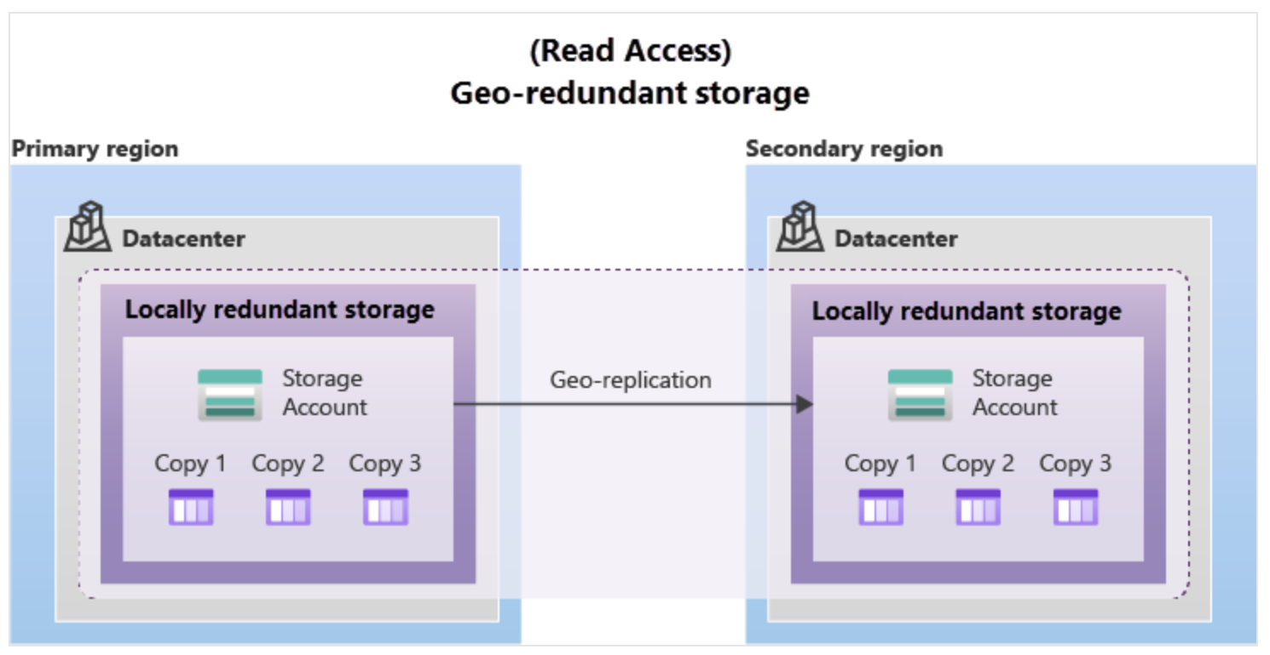

#### 

#### Geo-zone-redundant storage

GZRS combines the high availability provided by redundancy across availability zones with protection from regional outages provided by geo-replication. Data in a GZRS storage account is copied across three Azure availability zones in the primary region (similar to ZRS) and is also replicated to a secondary geographic region, using LRS, for protection from regional disasters. Microsoft recommends using GZRS for applications requiring maximum consistency, durability, and availability, excellent performance, and resilience for disaster recovery.

GZRS is designed to provide at least 16 nines (99.99999999999999%) of durability of objects over a given year.

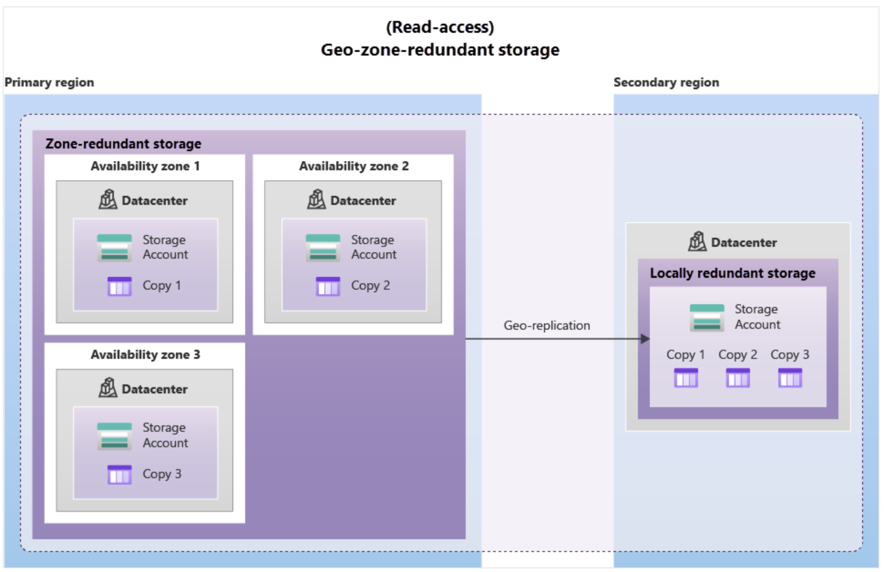

**Read access to data in the secondary region**

Geo-redundant storage (with GRS or GZRS) replicates your data to another physical location in the secondary region to protect against regional outages. However, that data is available to be read only if the customer or Microsoft initiates a failover from the primary to secondary region. However, if you enable read access to the secondary region, your data is always available, even when the primary region is running optimally. For read access to the secondary region, enable read-access geo-redundant storage (RA-GRS) or read-access geo-zone-redundant storage (RA-GZRS).

Important: Remember that the data in your secondary region may not be up-to-date due to RPO.

## **Storage services**

* Azure Blobs: A massively scalable object store for text and binary data. Also includes support for big data analytics through Data Lake Storage Gen2.
* Azure Files: Managed file shares for cloud or on-premises deployments.
* Azure Queues: A messaging store for reliable messaging between application components.
* Azure Disks: Block-level storage volumes for Azure VMs.
* Azure Tables: NoSQL table option for structured, non-relational data.

### Benefits of Azure Storage

Azure Storage services offer the following benefits for application developers and IT professionals:

* **Durable and highly available.** Redundancy ensures that your data is safe if transient hardware failures occur. You can also opt to replicate data across data centers or geographical regions for additional protection from local catastrophes or natural disasters. Data replicated in this way remains highly available if an unexpected outage occurs.
* **Secure**. All data written to an Azure storage account is encrypted by the service. Azure Storage provides you with fine-grained control over who has access to your data.
* **Scalable**. Azure Storage is designed to be massively scalable to meet the data storage and performance needs of today's applications.
* **Managed**. Azure handles hardware maintenance, updates, and critical issues for you.
* **Accessible.** Data in Azure Storage is accessible from anywhere in the world over HTTP or HTTPS. Microsoft provides client libraries for Azure Storage in a variety of languages, including .NET, Java, Node.js, Python, PHP, Ruby, Go, and others, as well as a mature REST API. Azure Storage supports scripting in Azure PowerShell or Azure CLI. And the Azure portal and Azure Storage Explorer offer easy visual solutions for working with your data.

#### Blobs

Azure Blob storage is an object storage solution for the cloud. It can store massive amounts of data, such as text or binary data. Azure Blob storage is unstructured, meaning that there are no restrictions on the kinds of data it can hold. Blob storage can manage thousands of simultaneous uploads, massive amounts of video data, constantly growing log files, and can be reached from anywhere with an internet connection.

Blobs aren't limited to common file formats. A blob could contain gigabytes of binary data streamed from a scientific instrument, an encrypted message for another application, or data in a custom format for an app you're developing. One advantage of blob storage over disk storage is that it doesn't require developers to think about or manage disks. Data is uploaded as blobs, and Azure takes care of the physical storage needs.

Blob storage is ideal for:

* Serving images or documents directly to a browser.
* Storing files for distributed access.
* Streaming video and audio.
* Storing data for backup and restore, disaster recovery, and archiving.
* Storing data for analysis by an on-premises or Azure-hosted service.

**Accessing blob storage**

Objects in blob storage can be accessed from anywhere in the world via HTTP or HTTPS. Users or client applications can access blobs via URLs, the Azure Storage REST API, Azure PowerShell, Azure CLI, or an Azure Storage client library. The storage client libraries are available for multiple languages, including .NET, Java, Node.js, Python, PHP, and Ruby.

**Blob storage tiers**

Data stored in the cloud can grow at an exponential pace. To manage costs for your expanding storage needs, it's helpful to organize your data based on attributes like frequency of access and planned retention period. Data stored in the cloud can be handled differently based on how it's generated, processed, and accessed over its lifetime. Some data is actively accessed and modified throughout its lifetime. Some data is accessed frequently early in its lifetime, with access dropping drastically as the data ages. Some data remains idle in the cloud and is rarely, if ever, accessed after it's stored. To accommodate these different access needs, Azure provides several access tiers, which you can use to balance your storage costs with your access needs.

Azure Storage offers different access tiers for your blob storage, helping you store object data in the most cost-effective manner. The available access tiers include:

* **Hot access tier:** Optimized for storing data that is accessed frequently (for example, images for your website).
* **Cool access tier**: Optimized for data that is infrequently accessed and stored for at least 30 days (for example, invoices for your customers).
* **Cold access tier:** Optimized for storing data that is infrequently accessed and stored for at least 90 days.
* **Archive access tier**: Appropriate for data that is rarely accessed and stored for at least 180 days, with flexible latency requirements (for example, long-term backups).

The following considerations apply to the different access tiers:

* Hot, cool, and cold access tiers can be set at the account level. The archive access tier isn't available at the account level.
* All can be set at the blob level, during or after upload.
* Data in the cool and cold access tiers can tolerate slightly lower availability, but still requires high durability, retrieval latency, and throughput characteristics similar to hot data. For cool and cold data, a lower availability service-level agreement (SLA) and higher access costs compared to hot data are acceptable trade-offs for lower storage costs.
* Archive storage stores data offline and offers the lowest storage costs, but also the highest costs to rehydrate and access data.

#### 

#### Files

Azure File storage offers fully managed file shares in the cloud that are accessible via the industry standard Server Message Block (SMB) or Network File System (NFS) protocols. Azure Files file shares can be mounted concurrently by cloud or on-premises deployments. SMB Azure file shares are accessible from Windows, Linux, and macOS clients. NFS Azure Files shares are accessible from Linux or macOS clients. Additionally, SMB Azure file shares can be cached on Windows Servers with Azure File Sync for fast access near where the data is being used.

**Azure Files key benefits:**

* Shared access: Azure file shares support the industry standard SMB and NFS protocols, meaning you can seamlessly replace your on-premises file shares with Azure file shares without worrying about application compatibility.
* Fully managed: Azure file shares can be created without the need to manage hardware or an OS. This means you don't have to deal with patching the server OS with critical security upgrades or replacing faulty hard disks.
* Scripting and tooling: PowerShell cmdlets and Azure CLI can be used to create, mount, and manage Azure file shares as part of the administration of Azure applications. You can create and manage Azure file shares using Azure portal and Azure Storage Explorer.
* Resiliency: Azure Files has been built from the ground up to always be available. Replacing on-premises file shares with Azure Files means you don't have to wake up in the middle of the night to deal with local power outages or network issues.
* Familiar programmability: Applications running in Azure can access data in the share via file system I/O APIs. Developers can therefore use their existing code and skills to migrate existing applications. In addition to System IO APIs, you can use Azure Storage Client Libraries or the Azure Storage REST API.

#### Azure Queues

Azure Queue storage is a service for storing large numbers of messages. Once stored, you can access the messages from anywhere in the world via authenticated calls using HTTP or HTTPS. A queue can contain as many messages as your storage account has room for (potentially millions). Each individual message can be up to 64 KB in size. Queues are commonly used to create a backlog of work to process asynchronously.

Queue storage can be combined with compute functions like Azure Functions to take an action when a message is received. For example, you want to perform an action after a customer uploads a form to your website. You could have the submit button on the website trigger a message to the Queue storage. Then, you could use Azure Functions to trigger an action once the message was received.

#### Azure Disks

Azure Disk storage, or Azure managed disks, are block-level storage volumes managed by Azure for use with Azure VMs. Conceptually, they’re the same as a physical disk, but they’re virtualized – offering greater resiliency and availability than a physical disk. With managed disks, all you have to do is provision the disk, and Azure will take care of the rest.

#### Azure Tables

Azure Table storage stores large amounts of structured data. Azure tables are a NoSQL datastore that accepts authenticated calls from inside and outside the Azure cloud. This enables you to use Azure tables to build your hybrid or multi-cloud solution and have your data always available. Azure tables are ideal for storing structured, non-relational data.

## Data migration options

Now that you understand the different storage options within Azure, it’s important to also understand how to get your data and information into Azure. Azure supports both real-time migration of infrastructure, applications, and data using Azure Migrate as well as asynchronous migration of data using Azure Data Box.

### Azure Migrate

Azure Migrate is a service that helps you migrate from an on-premises environment to the cloud. Azure Migrate functions as a hub to help you manage the assessment and migration of your on-premises datacenter to Azure. It provides the following:

* **Unified migration platform:** A single portal to start, run, and track your migration to Azure.
* **Range of tools**: A range of tools for assessment and migration. Azure Migrate tools include Azure Migrate: Discovery and assessment and Azure Migrate: Server Migration. Azure Migrate also integrates with other Azure services and tools, and with independent software vendor (ISV) offerings.
* **Assessment and migration:** In the Azure Migrate hub, you can assess and migrate your on-premises infrastructure to Azure.

#### 

#### Integrated tools

In addition to working with tools from ISVs, the Azure Migrate hub also includes the following tools to help with migration:

* **Azure Migrate:** **Discovery and assessment.** Discover and assess on-premises servers running on VMware, Hyper-V, and physical servers in preparation for migration to Azure.
* **Azure Migrate: Server Migration.** Migrate VMware VMs, Hyper-V VMs, physical servers, other virtualized servers, and public cloud VMs to Azure.
* **Data Migration Assistant**. Data Migration Assistant is a stand-alone tool to assess SQL Servers. It helps pinpoint potential problems blocking migration. It identifies unsupported features, new features that can benefit you after migration, and the right path for database migration.
* **Azure Database Migration Service.** Migrate on-premises databases to Azure VMs running SQL Server, Azure SQL Database, or SQL Managed Instances.
* **Azure App Service migration assistant**. Azure App Service migration assistant is a standalone tool to assess on-premises websites for migration to Azure App Service. Use Migration Assistant to migrate .NET and PHP web apps to Azure.
* **Azure Data Box.** Use Azure Data Box products to move large amounts of offline data to Azure.

### 

### Azure Data Box

Azure Data Box is a physical migration service that helps transfer large amounts of data in a quick, inexpensive, and reliable way. The secure data transfer is accelerated by shipping you a proprietary Data Box storage device that has a maximum usable storage capacity of 80 terabytes. The Data Box is transported to and from your datacenter via a regional carrier. A rugged case protects and secures the Data Box from damage during transit.

You can order the Data Box device via the Azure portal to import or export data from Azure. Once the device is received, you can quickly set it up using the local web UI and connect it to your network. Once you’re finished transferring the data (either into or out of Azure), simply return the Data Box. If you’re transferring data into Azure, the data is automatically uploaded once Microsoft receives the Data Box back. The entire process is tracked end-to-end by the Data Box service in the Azure portal.

#### Use cases

Data Box is ideally suited to transfer data sizes larger than 40 TBs in scenarios with no to limited network connectivity. The data movement can be one-time, periodic, or an initial bulk data transfer followed by periodic transfers.

Here are the various scenarios where Data Box can be used to **import data to Azure.**

* Onetime migration - when a large amount of on-premises data is moved to Azure.
* Moving a media library from offline tapes into Azure to create an online media library.
* Migrating your VM farm, SQL server, and applications to Azure.
* Moving historical data to Azure for in-depth analysis and reporting using HDInsight.
* Initial bulk transfer - when an initial bulk transfer is done using Data Box (seed) followed by incremental transfers over the network.
* Periodic uploads - when large amount of data is generated periodically and needs to be moved to Azure.

Here are the various scenarios where Data Box can be used to **export data from Azure.**

* Disaster recovery - when a copy of the data from Azure is restored to an on-premises network. In a typical disaster recovery scenario, a large amount of Azure data is exported to a Data Box. Microsoft then ships this Data Box, and the data is restored on your premises in a short time.
* Security requirements - when you need to be able to export data out of Azure due to government or security requirements.
* Migrate back to on-premises or to another cloud service provider - when you want to move all the data back to on-premises, or to another cloud service provider, export data via Data Box to migrate the workloads.

Once the data from your import order is uploaded to Azure, the disks on the device are wiped clean in accordance with NIST 800-88r1 standards. For an export order, the disks are erased once the device reaches the Azure datacenter.

## File movement options

In addition to large scale migration using services like Azure Migrate and Azure Data Box, Azure also has tools designed to help you move or interact with individual files or small file groups. Among those tools are AzCopy, Azure Storage Explorer, and Azure File Sync.

### AzCopy

AzCopy is a command-line utility that you can use to copy blobs or files to or from your storage account. With AzCopy, you can upload files, download files, copy files between storage accounts, and even synchronize files. AzCopy can even be configured to work with other cloud providers to help move files back and forth between clouds.

Important: Synchronizing blobs or files with AzCopy is one-direction synchronization. When you synchronize, you designate the source and destination, and AzCopy will copy files or blobs in that direction. It doesn't synchronize bi-directionally based on timestamps or other metadata.

### Azure Storage Explorer

Azure Storage Explorer is a standalone app that provides a graphical interface to manage files and blobs in your Azure Storage Account. It works on Windows, macOS, and Linux operating systems and uses AzCopy on the backend to perform all of the file and blob management tasks. With Storage Explorer, you can upload to Azure, download from Azure, or move between storage accounts.

### Azure File Sync

Azure File Sync is a tool that lets you centralize your file shares in Azure Files and keep the flexibility, performance, and compatibility of a Windows file server. It’s almost like turning your Windows file server into a miniature content delivery network. Once you install Azure File Sync on your local Windows server, it will automatically stay bi-directionally synced with your files in Azure.

With Azure File Sync, you can:

* Use any protocol that's available on Windows Server to access your data locally, including SMB, NFS, and FTPS.
* Have as many caches as you need across the world.
* Replace a failed local server by installing Azure File Sync on a new server in the same datacenter.
* Configure cloud tiering so the most frequently accessed files are replicated locally, while infrequently accessed files are kept in the cloud until requested.

# azure identity, access and security

## Azure directory services

Microsoft Entra ID is a directory service that enables you to sign in and access both Microsoft cloud applications and cloud applications that you develop. Microsoft Entra ID can also help you maintain your on-premises Active Directory deployment.

For on-premises environments, **Active Directory** running on Windows Server provides an identity and access management service that's managed by your organization. **Microsoft Entra ID** is Microsoft's cloud-based identity and access management service. With Microsoft Entra ID, you control the identity accounts, but Microsoft ensures that the service is available globally. If you've worked with Active Directory, Microsoft Entra ID will be familiar to you.

When you secure identities on-premises with Active Directory, Microsoft doesn't monitor sign-in attempts. When you connect Active Directory with Microsoft Entra ID, Microsoft can help protect you by detecting suspicious sign-in attempts at no extra cost. For example, Microsoft Entra ID can detect sign-in attempts from unexpected locations or unknown devices.

### Who uses Microsoft Entra ID?

Microsoft Entra ID is for:

* **IT administrators**. Administrators can use Microsoft Entra ID to control access to applications and resources based on their business requirements.
* **App developers**. Developers can use Microsoft Entra ID to provide a standards-based approach for adding functionality to applications that they build, such as adding SSO functionality to an app or enabling an app to work with a user's existing credentials.
* **Users**. Users can manage their identities and take maintenance actions like self-service password reset.
* **Online service subscribers.** Microsoft 365, Microsoft Office 365, Azure, and Microsoft Dynamics CRM Online subscribers are already using Microsoft Entra ID to authenticate into their account.

### What does Microsoft Entra ID do?

Microsoft Entra ID provides services such as:

* **Authentication**: This includes verifying identity to access applications and resources. It also includes providing functionality such as self-service password reset, multifactor authentication, a custom list of banned passwords, and smart lockout services.
* **Single sign-on (SSO):** SSO enables you to remember only one username and one password to access multiple applications. A single identity is tied to a user, which simplifies the security model. As users change roles or leave an organization, access modifications are tied to that identity, which greatly reduces the effort needed to change or disable accounts.
* **Application management**: You can manage your cloud and on-premises apps by using Microsoft Entra ID. Features like Application Proxy, SaaS apps, the My Apps portal, and single sign-on provide a better user experience.
* **Device management**: Along with accounts for individual people, Microsoft Entra ID supports the registration of devices. Registration enables devices to be managed through tools like Microsoft Intune. It also allows for device-based Conditional Access policies to restrict access attempts to only those coming from known devices, regardless of the requesting user account.

### Can I connect my on-premises AD with Microsoft Entra ID?

If you had an on-premises environment running Active Directory and a cloud deployment using Microsoft Entra ID, you would need to maintain two identity sets. However, you can connect Active Directory with Microsoft Entra ID, enabling a consistent identity experience between cloud and on-premises.

One method of connecting Microsoft Entra ID with your on-premises AD is using Microsoft Entra Connect. **Microsoft Entra Connect** synchronizes user identities between on-premises Active Directory and Microsoft Entra ID. Microsoft Entra Connect synchronizes changes between both identity systems, so you can use features like SSO, multifactor authentication, and self-service password reset under both systems.

### What is Microsoft Entra Domain Services?

Microsoft Entra Domain Services is a service that provides managed domain services such as domain join, group policy, lightweight directory access protocol (LDAP), and Kerberos/NTLM authentication. Just like Microsoft Entra ID lets you use directory services without having to maintain the infrastructure supporting it, with Microsoft Entra Domain Services, you get the benefit of domain services without the need to deploy, manage, and patch domain controllers (DCs) in the cloud.

A Microsoft Entra Domain Services managed domain lets you run legacy applications in the cloud that can't use modern authentication methods, or where you don't want directory lookups to always go back to an on-premises AD DS environment. You can lift and shift those legacy applications from your on-premises environment into a managed domain, without needing to manage the AD DS environment in the cloud.

Microsoft Entra Domain Services integrates with your existing Microsoft **Entra tenant.** This integration lets users sign into services and applications connected to the managed domain using their existing credentials. You can also use existing groups and user accounts to secure access to resources. These features provide a smoother lift-and-shift of on-premises resources to Azure.

#### How does Microsoft Entra Domain Services work?

When you create a Microsoft Entra Domain Services managed domain, you define a unique namespace. This namespace is the domain name. Two Windows Server domain controllers are then deployed into your selected Azure region. This deployment of DCs is known as a **replica set.**

You don't need to manage, configure, or update these DCs. The Azure platform handles the DCs as part of the managed domain, including backups and encryption at rest using Azure Disk Encryption.

#### Is information synchronized?

A managed domain is configured to perform a one-way synchronization from Microsoft Entra ID to Microsoft Entra Domain Services. You can create resources directly in the managed domain, but they aren't synchronized back to Microsoft Entra ID. In a hybrid environment with an on-premises AD DS environment, **Microsoft Entra Connect** synchronizes identity information with Microsoft Entra ID, which is then synchronized to the managed domain.

Applications, services, and VMs in Azure that connect to the managed domain can then use common Microsoft Entra Domain Services features such as domain join, group policy, LDAP, and Kerberos/NTLM authentication.

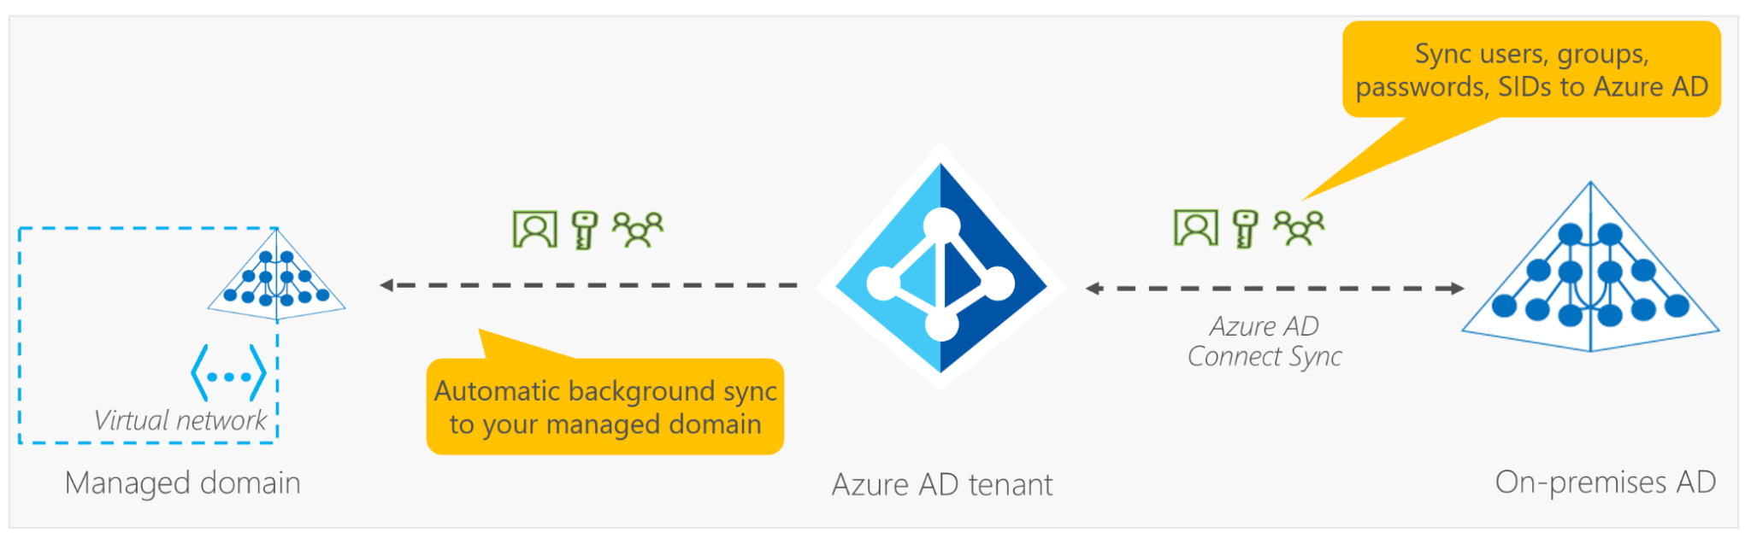

## Authentication methods

Authentication is the process of establishing the identity of a person, service, or device. It requires the person, service, or device to provide some type of credential to prove who they are. Authentication is like presenting ID when you’re traveling. It doesn’t confirm that you’re ticketed, it just proves that you're who you say you are. Azure supports multiple authentication methods, including standard passwords, single sign-on (SSO), multifactor authentication (MFA), and passwordless.

For the longest time, security and convenience seemed to be at odds with each other. Thankfully, new authentication solutions provide both security and convenience.

The following diagram shows the security level compared to the convenience. Notice Passwordless authentication is high security and high convenience while passwords on their own are low security but high convenience.

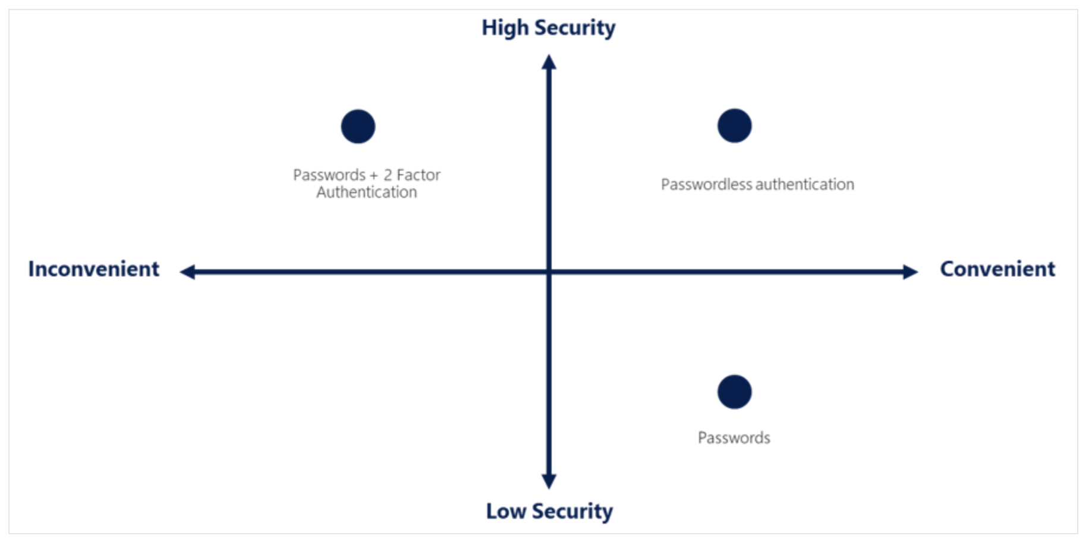

### What's single sign-on?

Single sign-on (SSO) enables a user to sign in one time and use that credential to access multiple resources and applications from different providers. For SSO to work, the different applications and providers must trust the initial authenticator.

More identities mean more passwords to remember and change. Password policies can vary among applications. As complexity requirements increase, it becomes increasingly difficult for users to remember them. The more passwords a user has to manage, the greater the risk of a credential-related security incident.

Consider the process of managing all those identities. More strain is placed on help desks as they deal with account lockouts and password reset requests. If a user leaves an organization, tracking down all those identities and ensuring they're disabled can be challenging. If an identity is overlooked, this might allow access when it should have been eliminated.

With SSO, you need to remember only one ID and one password. Access across applications is granted to a single identity that's tied to the user, which simplifies the security model. As users change roles or leave an organization, access is tied to a single identity. This change greatly reduces the effort needed to change or disable accounts. Using SSO for accounts makes it easier for users to manage their identities and for IT to manage users.

Important: Single sign-on is only as secure as the initial authenticator because the subsequent connections are all based on the security of the initial authenticator.

### What’s multifactor authentication?

Multifactor authentication is the process of prompting a user for an extra form (or factor) of identification during the sign-in process. MFA helps protect against a password compromise in situations where the password was compromised but the second factor wasn't.

Think about how you sign into websites, email, or online services. After entering your username and password, have you ever needed to enter a code that was sent to your phone? If so, you've used multifactor authentication to sign in.

Multifactor authentication provides additional security for your identities by requiring two or more elements to fully authenticate. These elements fall into three categories:

* Something the user knows – this might be a challenge question.
* Something the user has – this might be a code that's sent to the user's mobile phone.
* Something the user is – this is typically some sort of biometric property, such as a fingerprint or face scan.

Multifactor authentication increases identity security by limiting the impact of credential exposure (for example, stolen usernames and passwords). With multifactor authentication enabled, an attacker who has a user's password would also need to have possession of their phone or their fingerprint to fully authenticate.

#### What's Microsoft Entra multifactor authentication?

Microsoft Entra multifactor authentication is a Microsoft service that provides multifactor authentication capabilities. Microsoft Entra multifactor authentication enables users to choose an additional form of authentication during sign-in, such as a phone call or mobile app notification.

### 

### What’s passwordless authentication?

Features like MFA are a great way to secure your organization, but users often get frustrated with the additional security layer on top of having to remember their passwords. People are more likely to comply when it's easy and convenient to do so. Passwordless authentication methods are more convenient because the password is removed and replaced with something you have, plus something you are, or something you know.

Passwordless authentication needs to be set up on a device before it can work. For example, your computer is something you have. Once it’s been registered or enrolled, Azure now knows that it’s associated with you. Now that the computer is known, once you provide something you know or are (such as a PIN or fingerprint), you can be authenticated without using a password.

Each organization has different needs when it comes to authentication. Microsoft global Azure and Azure Government offer the following three passwordless authentication options that integrate with Microsoft Entra ID:

* Windows Hello for Business
* Microsoft Authenticator app
* FIDO2 security keys

#### 

#### Windows Hello for Business

Windows Hello for Business is ideal for information workers that have their own designated Windows PC. The biometric and PIN credentials are directly tied to the user's PC, which prevents access from anyone other than the owner. With public key infrastructure (PKI) integration and built-in support for single sign-on (SSO), Windows Hello for Business provides a convenient method for seamlessly accessing corporate resources on-premises and in the cloud.

#### Microsoft Authenticator App

You can also allow your employee's phone to become a passwordless authentication method. You may already be using the Microsoft Authenticator App as a convenient multifactor authentication option in addition to a password. You can also use the Authenticator App as a passwordless option.

The Authenticator App turns any iOS or Android phone into a strong, passwordless credential. Users can sign-in to any platform or browser by getting a notification to their phone, matching a number displayed on the screen to the one on their phone, and then using their biometric (touch or face) or PIN to confirm. Refer to Download and install the Microsoft Authenticator app for installation details.

#### FIDO2 security keys

The FIDO (Fast IDentity Online) Alliance helps to promote open authentication standards and reduce the use of passwords as a form of authentication. FIDO2 is the latest standard that incorporates the web authentication (WebAuthn) standard.

FIDO2 security keys are an unphishable standards-based passwordless authentication method that can come in any form factor. Fast Identity Online (FIDO) is an open standard for passwordless authentication. FIDO allows users and organizations to leverage the standard to sign-in to their resources without a username or password by using an external security key or a platform key built into a device.

Users can register and then select a FIDO2 security key at the sign-in interface as their main means of authentication. These FIDO2 security keys are typically USB devices, but could also use Bluetooth or NFC. With a hardware device that handles the authentication, the security of an account is increased as there's no password that could be exposed or guessed.

## External identities

An external identity is a person, device, service, etc. that is outside your organization. Microsoft Entra External ID refers to all the ways you can securely interact with users outside of your organization. If you want to collaborate with partners, distributors, suppliers, or vendors, you can share your resources and define how your internal users can access external organizations. If you're a developer creating consumer-facing apps, you can manage your customers' identity experiences.

External identities may sound similar to single sign-on. With External Identities, external users can "bring their own identities." Whether they have a corporate or government-issued digital identity, or an unmanaged social identity like Google or Facebook, they can use their own credentials to sign in. The external user’s identity provider manages their identity, and you manage access to your apps with Microsoft Entra ID or Azure AD B2C to keep your resources protected.

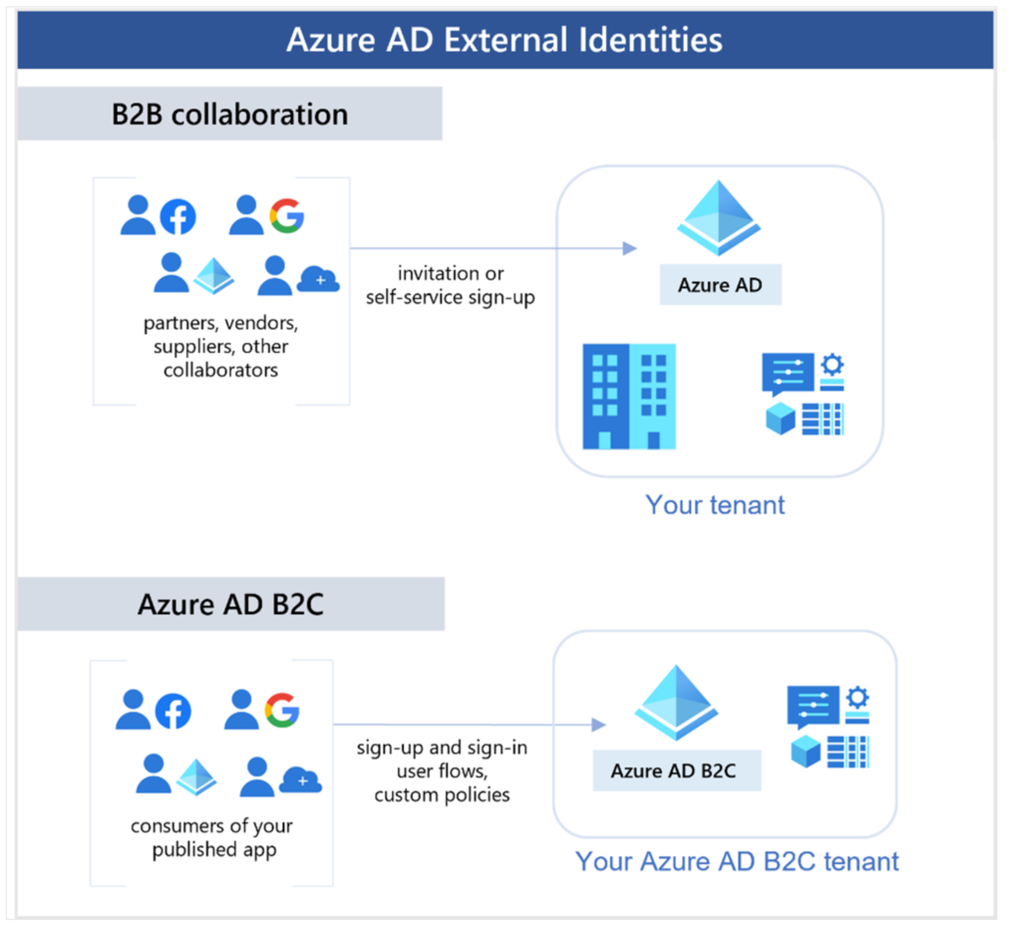

The following capabilities make up External Identities:

* **Business to business (B2B) collaboration** - Collaborate with external users by letting them use their preferred identity to sign-in to your Microsoft applications or other enterprise applications (SaaS apps, custom-developed apps, etc.). B2B collaboration users are represented in your directory, typically as guest users.
* **B2B direct connect** - Establish a mutual, two-way trust with another Microsoft Entra organization for seamless collaboration. B2B direct connect currently supports Teams shared channels, enabling external users to access your resources from within their home instances of Teams. B2B direct connect users aren't represented in your directory, but they're visible from within the Teams shared channel and can be monitored in Teams admin center reports.
* **Microsoft Entra business to customer (B2C)** - Publish modern SaaS apps or custom-developed apps (excluding Microsoft apps) to consumers and customers, while using Azure AD B2C for identity and access management.

Depending on how you want to interact with external organizations and the types of resources you need to share, you can use a combination of these capabilities.

With Microsoft Entra ID, you can easily enable collaboration across organizational boundaries by using the Microsoft Entra B2B feature. Guest users from other tenants can be invited by administrators or by other users. This capability also applies to social identities such as Microsoft accounts.

You also can easily ensure that guest users have appropriate access. You can ask the guests themselves or a decision maker to participate in an access review and recertify (or attest) to the guests' access. The reviewers can give their input on each user's need for continued access, based on suggestions from Microsoft Entra ID. When an access review is finished, you can then make changes and remove access for guests who no longer need it.

## Zero trust model

Zero Trust is a security model that assumes the worst case scenario and protects resources with that expectation. Zero Trust assumes breach at the outset, and then verifies each request as though it originated from an uncontrolled network.

Today, organizations need a new security model that effectively adapts to the complexity of the modern environment; embraces the mobile workforce: and protects people, devices, applications, and data wherever they're located.

To address this new world of computing, Microsoft highly recommends the Zero Trust security model, which is based on these guiding principles:

* **Verify explicitly** - Always authenticate and authorize based on all available data points.
* **Use least privilege access** - Limit user access with Just-In-Time and Just-Enough-Access (JIT/JEA), risk-based adaptive policies, and data protection.
* **Assume breach** - Minimize blast radius and segment access. Verify end-to-end encryption. Use analytics to get visibility, drive threat detection, and improve defenses.

### 

### Adjusting to Zero Trust

Traditionally, corporate networks were restricted, protected, and generally assumed safe. Only managed computers could join the network, VPN access was tightly controlled, and personal devices were frequently restricted or blocked.

The Zero Trust model flips that scenario. Instead of assuming that a device is safe because it’s within the corporate network, it requires everyone to authenticate. Then grants access based on authentication rather than location.

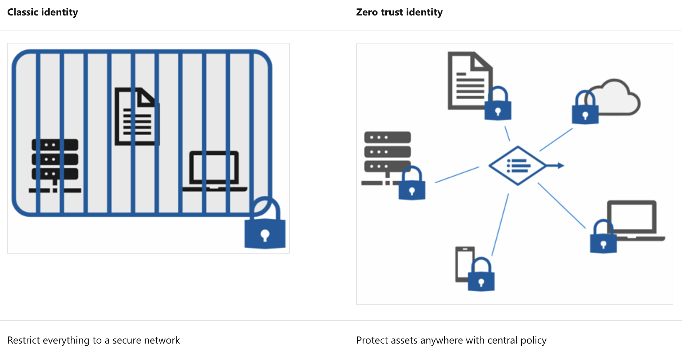

## Defense-in-depth

The objective of defense-in-depth is to protect information and prevent it from being stolen by those who aren't authorized to access it. A defense-in-depth strategy uses a series of mechanisms to slow the advance of an attack that aims at acquiring unauthorized access to data.

### Layers of defense-in-depth

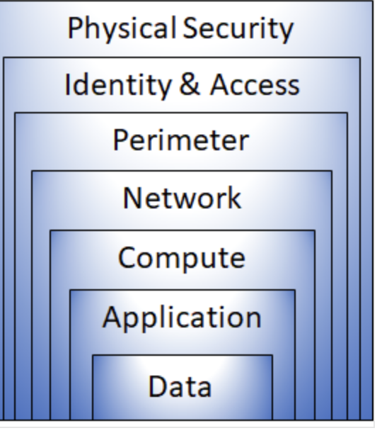

You can visualize defense-in-depth as a set of layers, with the data to be secured at the center and all the other layers functioning to protect that central data layer.

Each layer provides protection so that if one layer is breached, a subsequent layer is already in place to prevent further exposure. This approach removes reliance on any single layer of protection. It slows down an attack and provides alert information that security teams can act upon, either automatically or manually.

Here's a brief overview of the role of each layer:

* **The physical security** layer is the first line of defense to protect computing hardware in the datacenter.
* **The identity and access layer** controls access to infrastructure and change control.
* **The perimeter** layer uses distributed denial of service (DDoS) protection to filter large-scale attacks before they can cause a denial of service for users.
* **The network** layer limits communication between resources through segmentation and access controls.
* **The compute** layer secures access to virtual machines.
* **The application** layer helps ensure that applications are secure and free of security vulnerabilities.
* **The data** layer controls access to business and customer data that you need to protect.

These layers provide a guideline for you to help make security configuration decisions in all of the layers of your applications. Azure provides security tools and features at every level of the defense-in-depth concept. Let's take a closer look at each layer:

#### Physical security

Physically securing access to buildings and controlling access to computing hardware within the datacenter are the first line of defense.

With physical security, the intent is to provide physical safeguards against access to assets. These safeguards ensure that other layers can't be bypassed, and loss or theft is handled appropriately. Microsoft uses various physical security mechanisms in its cloud datacenters.

#### Identity and access

The identity and access layer is all about ensuring that identities are secure, that access is granted only to what's needed, and that sign-in events and changes are logged.

At this layer, it's important to:

* Control access to infrastructure and change control.
* Use single sign-on (SSO) and multifactor authentication.
* Audit events and changes.

#### Perimeter

The network perimeter protects from network-based attacks against your resources. Identifying these attacks, eliminating their impact, and alerting you when they happen are important ways to keep your network secure.

At this layer, it's important to:

* Use DDoS protection to filter large-scale attacks before they can affect the availability of a system for users.
* Use perimeter firewalls to identify and alert on malicious attacks against your network.

#### Network

At this layer, the focus is on limiting the network connectivity across all your resources to allow only what's required. By limiting this communication, you reduce the risk of an attack spreading to other systems in your network.

At this layer, it's important to:

* Limit communication between resources.
* Deny by default.
* Restrict inbound internet access and limit outbound access where appropriate.
* Implement secure connectivity to on-premises networks.

#### Compute

Malware, unpatched systems, and improperly secured systems open your environment to attacks. The focus in this layer is on making sure that your compute resources are secure and that you have the proper controls in place to minimize security issues.

At this layer, it's important to:

* Secure access to virtual machines.
* Implement endpoint protection on devices and keep systems patched and current.

#### Application

Integrating security into the application development lifecycle helps reduce the number of vulnerabilities introduced in code. Every development team should ensure that its applications are secure by default.

At this layer, it's important to:

* Ensure that applications are secure and free of vulnerabilities.
* Store sensitive application secrets in a secure storage medium.
* Make security a design requirement for all application development.

#### Data

Those who store and control access to data are responsible for ensuring that it's properly secured. Often, regulatory requirements dictate the controls and processes that must be in place to ensure the confidentiality, integrity, and availability of the data.

In almost all cases, attackers are after data:

* Stored in a database.
* Stored on disk inside virtual machines.
* Stored in software as a service (SaaS) applications, such as Office 365.
* Managed through cloud storage.

# 

# 

# 

# 

# 

# 

# 

# 

# 

# 

# 

# Microsoft ENTRA ID

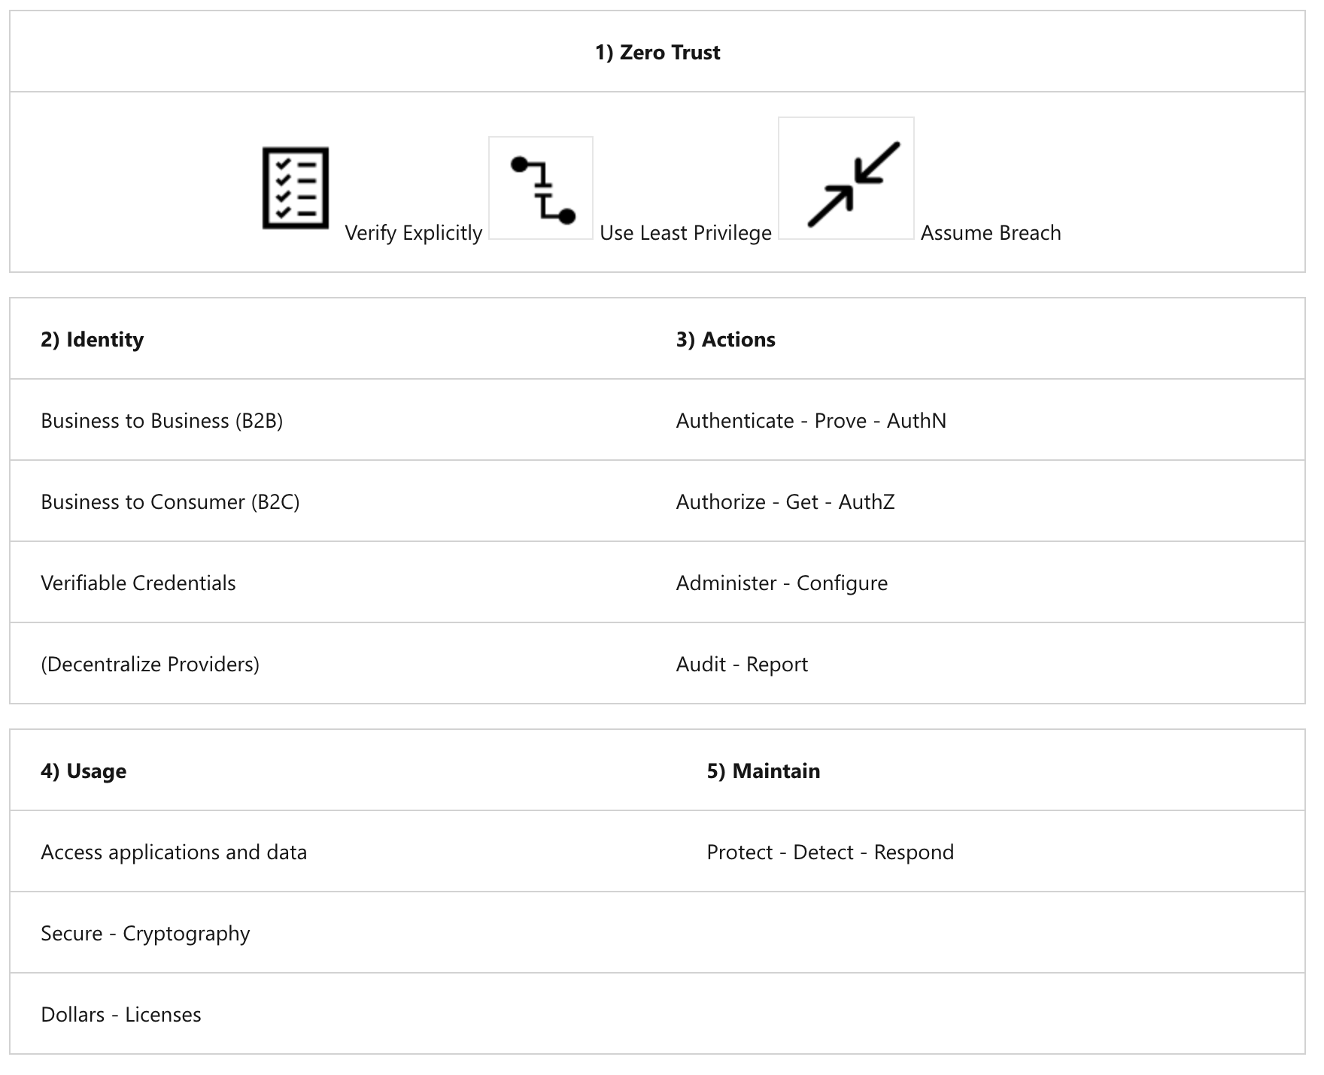

1. **Zero trust**: First you have the guidance of always thinking and designing with zero trust in mind. Don't just give access to data and applications because the user has had access previously. You need to always confirm.
2. **Identity**: Second you have systems to provide verified accounts for users and applications. Identity services come from Microsoft Entra ID, from business-to-business federation, from business-to-customer, and from decentralized identity providers.
3. **Actions:** Third you have specific actions identity provides and to keep the systems running. Users and applications can authenticate and authorize to gain access to systems. And administrators need to monitor and maintain the identity systems with proper governance.
4. **Usage:** Fourth you get many actions that can be performed once your credentials are verified. Use applications and data, while taking advantage of other identity based services.
5. **Maintain:** Fifth and finally, you need to always keep your systems up to date.

**From classic identity to zero trust identity**

Historically, identity kept all your assets behind the firewall. Submit a username and password to get through the gate, and you had full access to everything. In the modern world, with the large number of cyber-attacks securing just the network doesn't work. One lost or stolen credential and bad actors have access to everything. With zero trust, you protect your assets anywhere with policy.



## **Zero Trust**

Organizations need a new security model that adapts to the complexity of the hybrid and multicloud environments. Support is required for the cloud environment, embracing the mobile workforce, and protecting people, devices, applications, and data wherever they're located. Zero Trust is the core strategy. Instead of believing everything behind the corporate firewall is safe, the Zero Trust model assumes breach and verifies each request as though it originated from an uncontrolled network. Regardless of where the request originates or what resource it accesses, the Zero Trust model teaches us to "never trust, always verify."

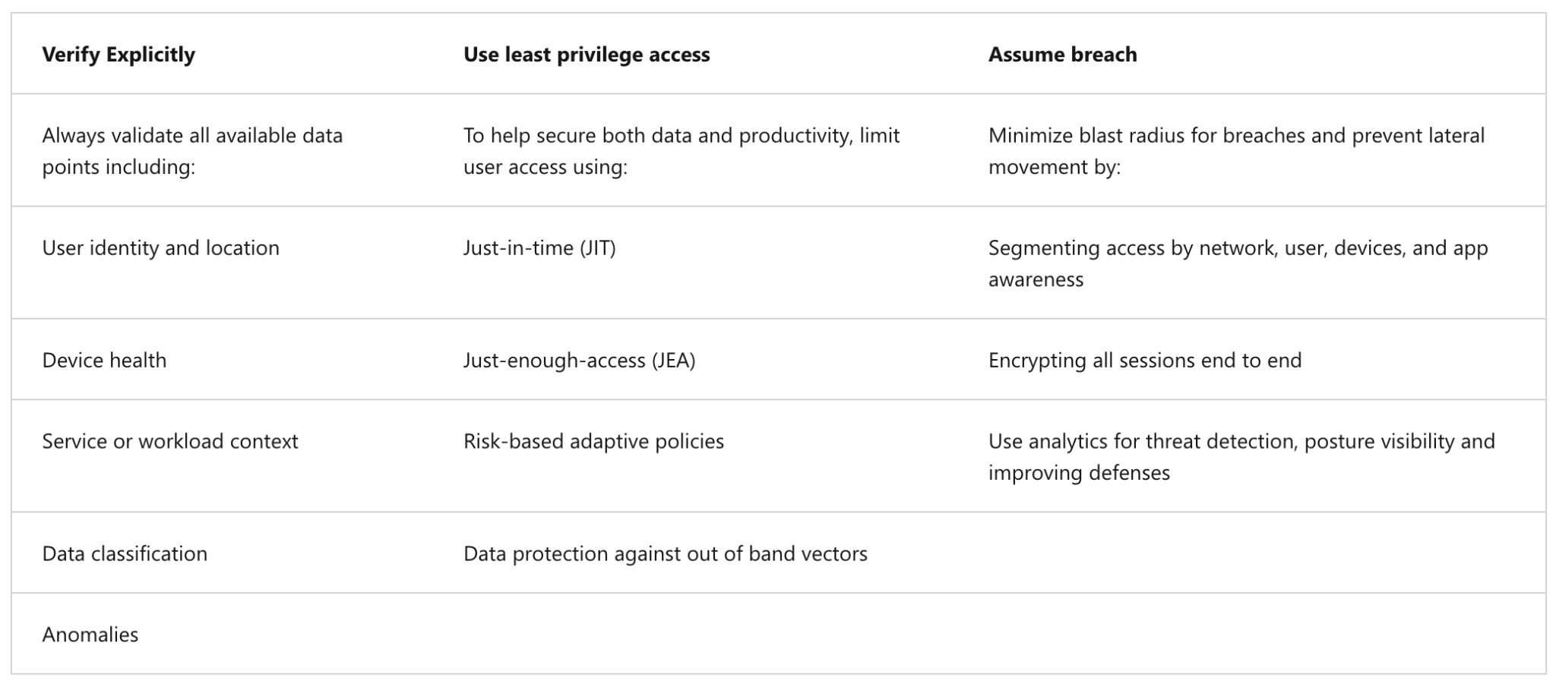

A Zero Trust approach should extend throughout the entire digital estate and serve as an integrated security philosophy and end-to-end strategy. You need to implement Zero Trust controls and technologies across six foundational elements. Each element is a source of signal, a control plane for enforcement, and a critical resource to be defended.

For this content, we're going to focus specifically on the security identity with zero trust pillar. Identities, whether they represent people, services, or IoT devices define the Zero Trust control plane. When an identity attempts to access a resource, verify that identity with strong authentication, and ensure access is compliant and typical for that identity. Follow least privilege access principles.

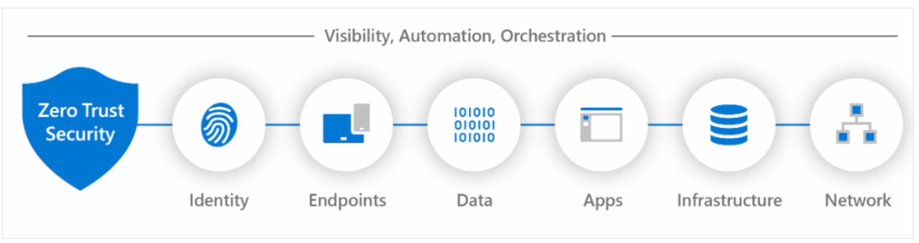

#### **Zero Trust Architecture**

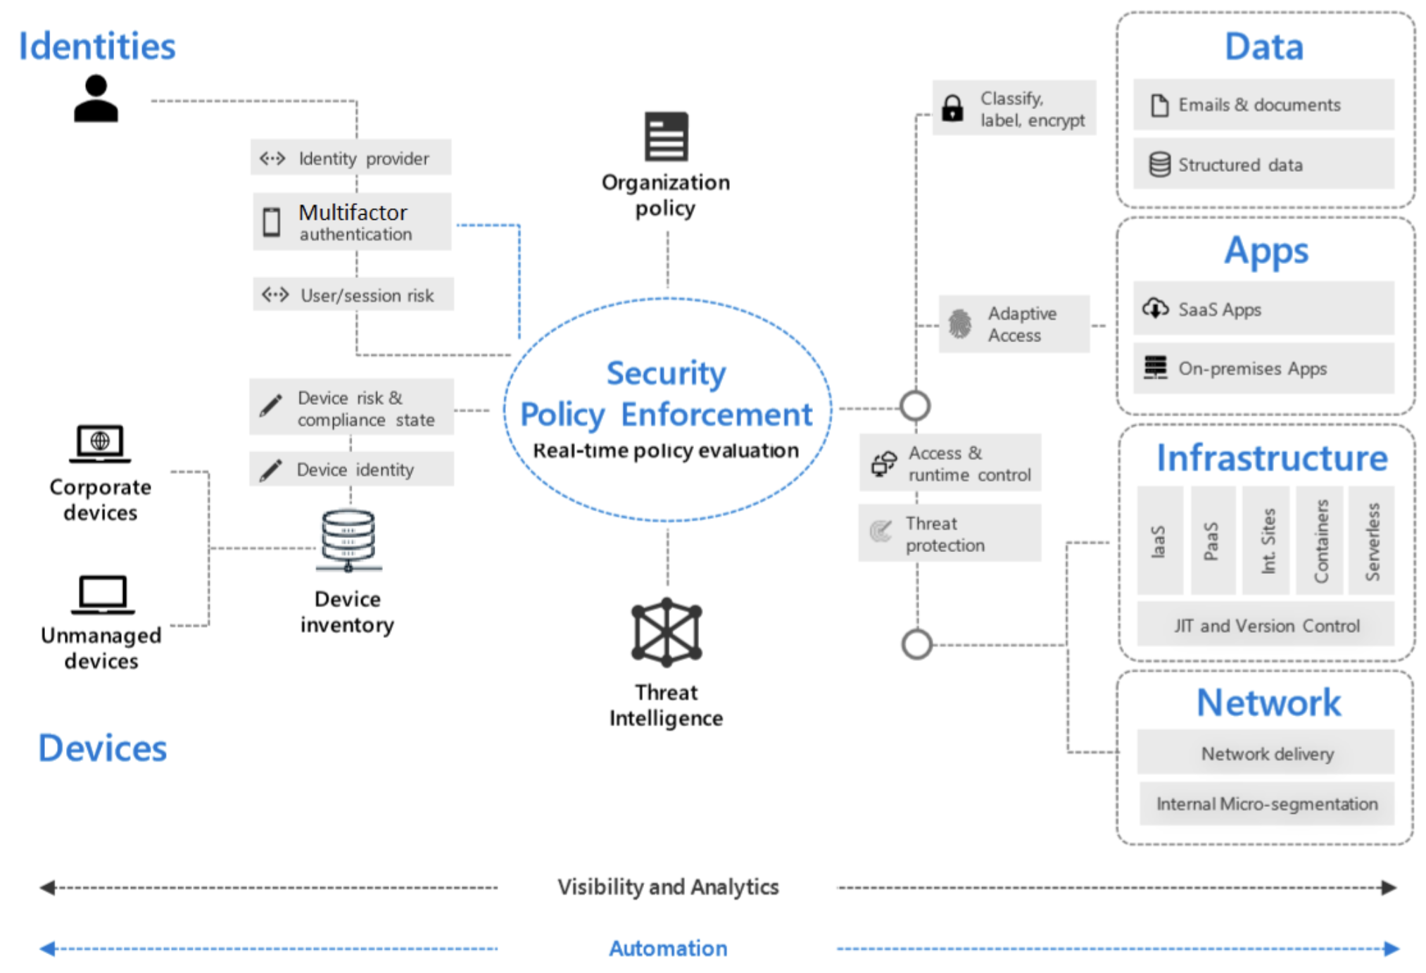

Security policy governs everything. Identity is used to verify identity and access. Additionally, the diagram has blocks for data, apps, networking, and infrastructure radiating outward.

An integrated set of solutions and capabilities offer built-in Zero Trust controls that make implementing a Zero Trust security model across your organization achievable at scale. At the heart of your Zero Trust strategy, you need a **policy engine** to make dynamic access decisions for trusted users at critical checkpoints—access to networks, apps, and data. Identity and access management and endpoint-management solutions enable your organization to verify users and devices explicitly. Verification is done with rich signal, such as device health and sign-in risk. Looking at the signal enables systems to make informed decisions based on access policies.

Information protection and cloud security solutions help enforce decisions and protect resources across the entire environment in real time. Networking solutions help use real-time threat protection to detect and respond to threats across your networks and infrastructure.

Finally, the integrated security information and event management (SIEM) and extended detection and response (XDR) solutions to deliver true, end-to-end threat prevention, detection, and response. Together, **Microsoft SIEM + XDR** provide your organization visibility into threats across all your resources, stitch signals together to tell you what is most important and enable you to respond swiftly with integrated remediation capabilities. An intelligent security approach helps ensure that only the right people are getting the right level of access across your organization, elevating both security and end-user productivity.

## **Identity**

### **Identity as a control plane**

First, we should probably answer the question - what is a control plane? A control plane is a term that has been used for years within networks. It's the part of a network that routes network traffic around the network architecture. So, a control plane is a tool or service that directs access to resources based on specific criteria. When it comes to solutions in today's world, the user identity is the right place to check for access. This sets up identity as the control plane.

With the many networks, devices, and applications needed in daily business, the only common denominator is the user. This is why we say, Identity is the control plane. It’s critical to establish who the user is as the core of trust for other transactions. If we aren’t sure who the user is, no other system access control or security matters. Once we're sure of the user, we can explicitly verify every element of access whether our resources are on-premises, in cloud-hosted servers, or managed by third-party SaaS apps like Office 365.

### **Why use it?**

It gives the ability:

* To prove who or what, we are - Authentication
* To get permissions to do something - Authorization
* To report on what was done - Auditing
* To IT manage and self administer an identity - Administration

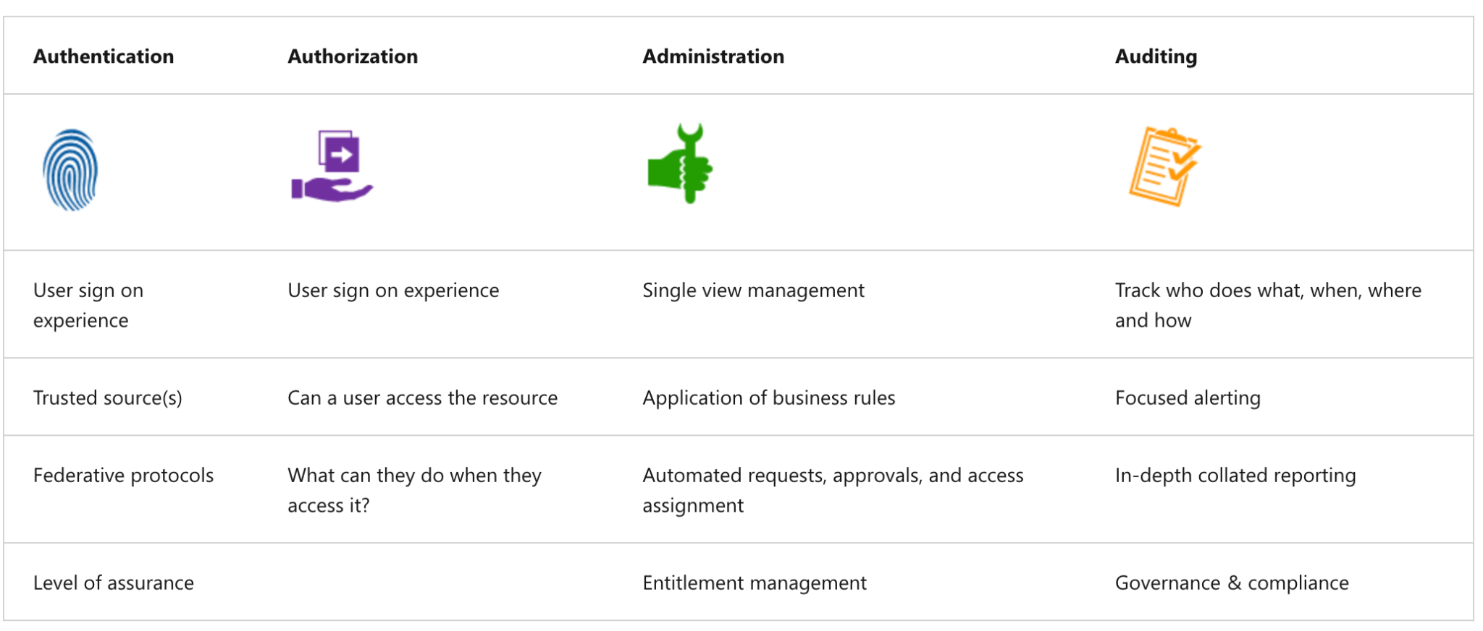

#### **Identity provider (IdP)**

An identity provider (IdP) is a system that creates, manages and stores digital identities. **Microsoft Entra ID** is an example. The capabilities and features of identity providers can vary. The most common components are:

* A repository of user identities
* An authentication system
* Security protocols that defend against intrusion
* Someone we trust

An identity provider verifies user identities using one or more authentication factors, such as a password or fingerprint scan. An identity provider is often a trusted provider for use with single-sign-on (SSO) to access other resources. SSO enhances usability by reducing password fatigue. It also provides better security by decreasing the potential attack surface. Identity providers can facilitate connections between cloud computing resources and users, thus decreasing the need for users to reauthenticate when using mobile and roaming applications.

#### **Common identity protocols**

* **OpenID provider - OpenID Connect (OIDC**) is an authentication protocol based on the OAuth2 protocol (which is used for authorization). OIDC uses the standardized message flows from OAuth2 to provide identity services. Specifically, a system entity (called an OpenID-Provider) issues JSON-formatted identity tokens to OIDC relying parties via a RESTful HTTP API.
* **SAML identity provider - Security Assertion Markup Language (SAML)** is an open standard for exchanging authentication and authorization data between an identity provider and a service provider. SAML is an XML-based markup language for security assertions, which are statements that service providers use to make access-control decisions.